ITie Official Publication of ALOA—An International Association of Security Professionals

June

[www.aloa.org](http://www.aloa.org)

INSIDE

High Security Switchouts

Examining the Latest Medeco and

Assa High Security 1C Upgrades

PLUS

The English Mark IV Manifoil  
"Hockey Puck"  
High Security Safe Lock,

Lock-Picking Mysteries, Pt. 1,  
Auto Transponders:  
Brave New World,  
Liberty Gun Safe,  
ALOA Exhibitor and  
Class Lists,  
Legislative News

and Much More!

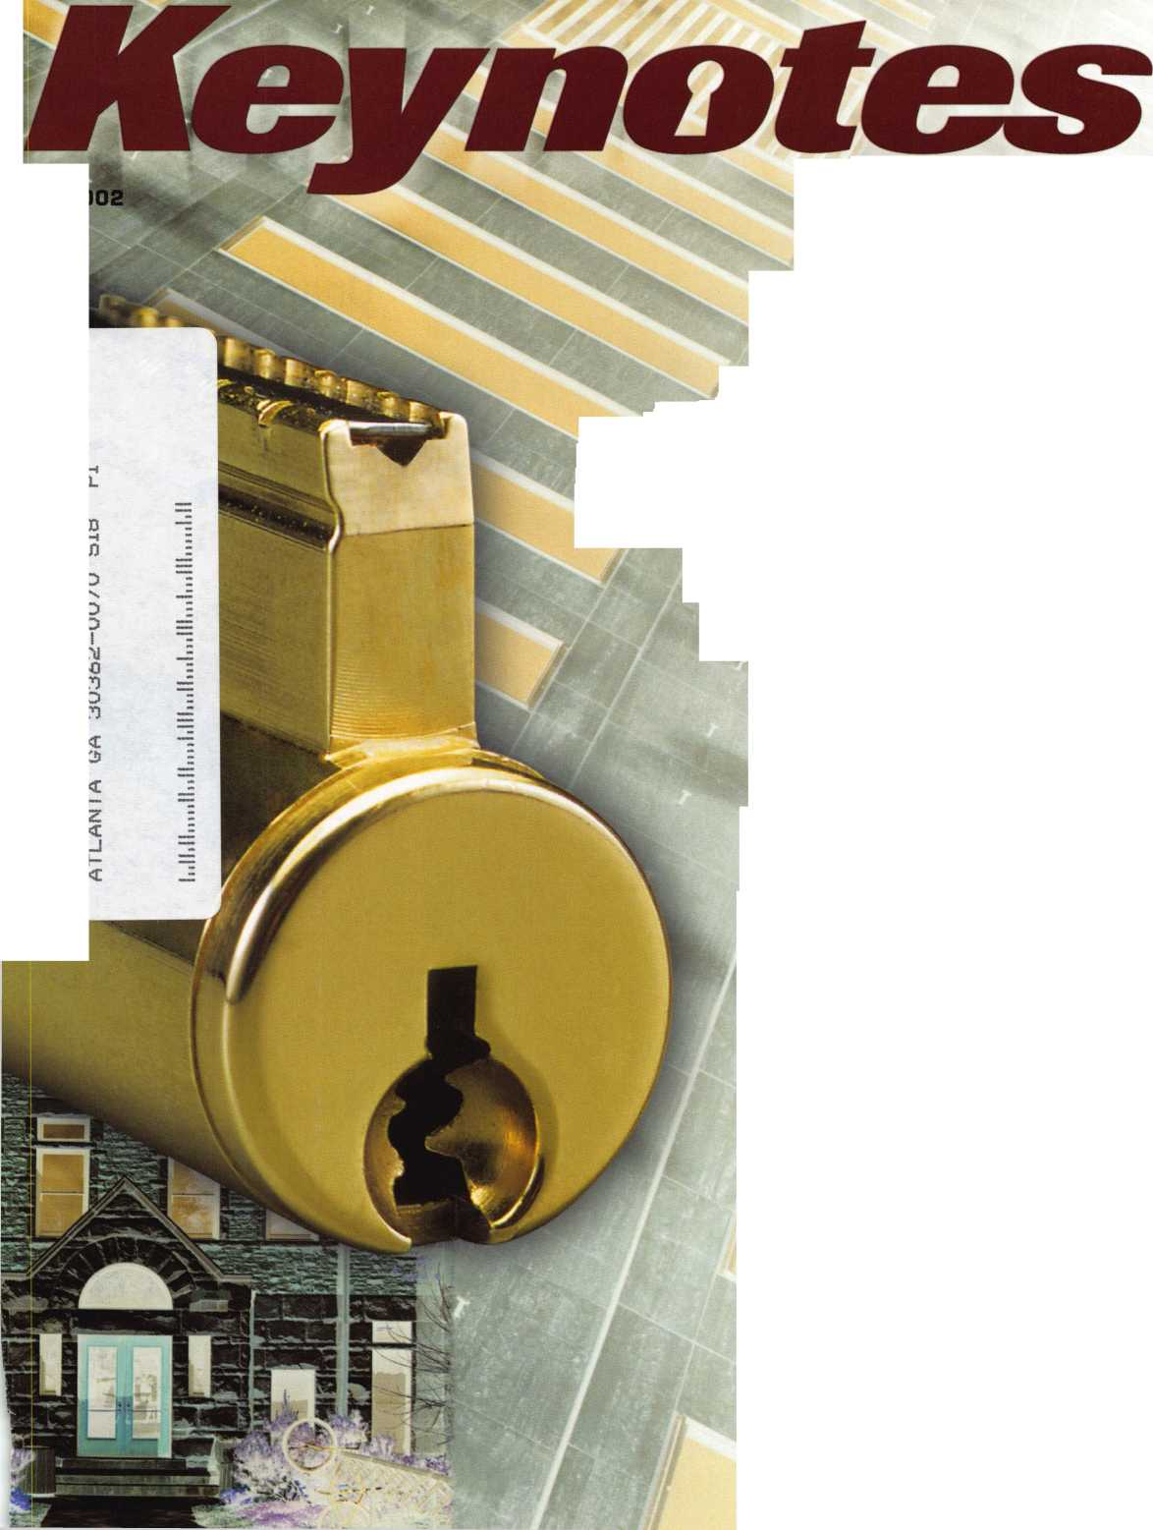

**Delayed Egress**

**That Forgives Almost Everything...**

But

Unauthorized

Exits

Now there’s a delayed egress magnetic lock  
that forgives life’s imperfections. The DynaLock 3101B  
compensates for door sag and misalignment with a  
simple, thumbwheel adjustment. What’s more, it protects  
against improper wiring with self-resetting protection for  
its microprocessor and circuitry. And even the electronics  
are field-programmable and upgradeable.

The 3101B Delayed Egress magnetic lock is fully  
self-contained, so installation is easy... no external  
wiring is necessary except power. And the combination  
mechanical/opto-electricai sensor is nearly foolproof.  
The 1500 lb. holding force offers high security with user-  
programmable delay, fire alarm tie-in, bypass and alarm  
monitoring. Meets all relevant life safety and security  
codes, including NFPA 101.

For high security in an imperfect world,

©

DynaLock



Call today:

877-DYNALOCK (877-396-2562) or visit: dynalock.com

DynaLock

Electromagnetic Locking Systems

DynaLock Corporation

705 Emmett Street, P.O. Box 2728 Bristol, CT 06011-2728 FAX 860/585-0338 i nfo@dynalock. com

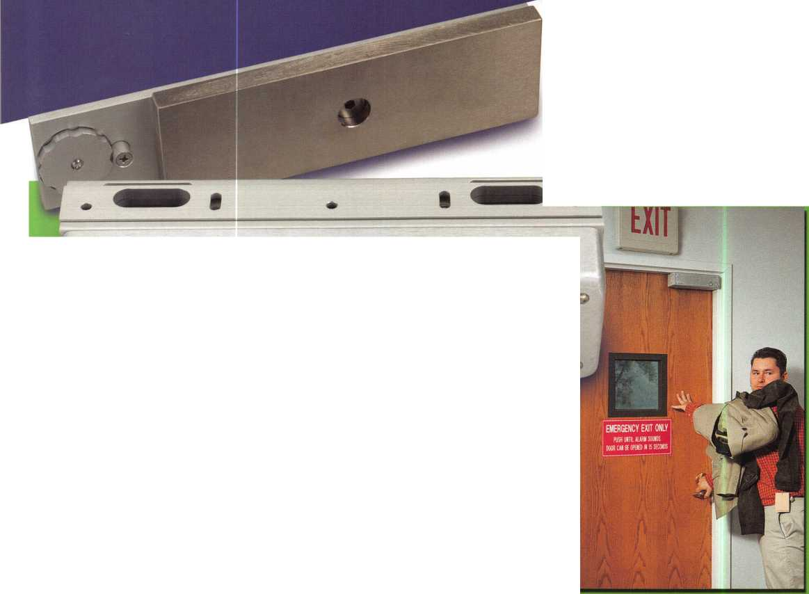

ALOA 2002

Secure Your Reservation Now!

Your individual success as a locksmith is what the annual ALOA convention is all about.

Make a secure investment in your future!

Register today and take advantage of the best selection of classes and travel accommodation values.

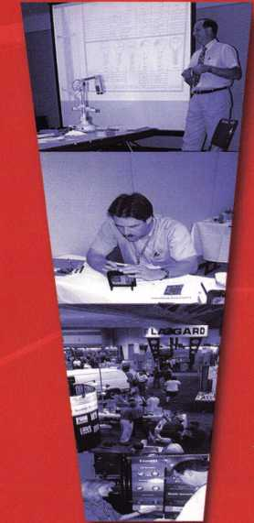

*Qj*

*meUea*

Don’t Miss These Classes!

**TRADITIONAL**

**LOCKSMITHING CLASSES:**

*Fundamentals of Locksmithing (5 days)*

Basic SFIC, Corbin Russwin, Schlage and Yale 1C hands on Master Keying Methods & Formats (2 days)

Advanced Topics in Master keying Exit devices & Exit Alarms Servicing Aluminum Storefront Doors

Complete Door and Door Closers Hollow Metal Door &

Frame Servicing Medeco Biaxial

Factory Certification Investigative Locksmithing (3 days) Forensic Locksmithing Life Safety Codes and ADA Detex Advantex

Studying for and Passing the PRP Professional Bypass Techniques Mechanical Push Button Lock Manipulation Comprehensive Interchangeable Core (2 days)

Simplex Unican Certification Servicing Schlage Commercial Products American Padlock Certification Master Pro Series Certification Mul-T-Lock

Medeco Keymark Certification Medeco New Product Update Primus/Everest Certification Rekey Project Management ABUS Padlock Certification ASSA High Security Locks Product ABLOY PROTEC High Security Locks Electrified Closers and Door Controls

HPC Codes & Code Machine Concepts Key Systems & Automated Key Production Yale Cylinders &

Master-keying Certification Fire Door Hardware Van Lock/VanTech 21 PDQ Revolution Mortise Lock Program

**SAFE & VAULT**

**LOCKSMITHING CLASSES:**

Basic Safe Penetration Kaba Mas Series Locks Kaba Mas-FF-L-2740A Approved Lock Certification Safe Combination Lock

Servicing & Troubleshooting *Combination Lock Manipulation (2 days)*

S&G Group 2/2m Certification S&G Electronic Lock Certification LaGard Electronic Lock Certification (2 days)

**AUTOMOTIVE**

**LOCKSMITHING CLASSES:**

*GM Steering Column Service/Repair (2 days)*

Basic Automotive Lock Service Intermediate Automotive Lock Service

Advanced Automotive Lock Service Motorcycle Locksmithing 21 st Century Car Opening Transponders 2002 Automotive Key Generation STRATTEC 2003 1 3 Methods of Car Opening 2002-2003 Kaba llco Automotive Update Transponders 2002/2003 Automotive Picking Techniques Auto Opening Techniques 2002

**ELECTRONIC LOCKSMITHING CLASSES:**

Electronic Safe Lock Servicing *Alarm Design and Development (2 days)*

*Comprehensive Access Control (2 days)*

Basic Electricity Introduction to Access Control Basic Electricity

*Electronic Access Control Entry Level Installer (2 days)*

AMSEC Electronic

Access Control Certification Folger Adam Electric Door Controls l-Que Elec. Access Control Certification

Introduction to Access Control with Cyberlock Videx Cyberlock Advanced Training Proximity Access Control by SecuraKey

Alarm Lock Trilogy Certification Complete Guide to Electric Strikes Millenium Entry Systems The SafeWizard™ Access Control System

**LOCKSMITH BUSINESS CLASSES:**

What is my time worth? OR How much should I charge?

*Financial Management for Locksmiths (2 days)*

Business Planning Advanced Shop Management Increase Your Revenues by 25% This Year

Making $ Selling Cash/

Handling Safes Instructor Training (3 days) Improving Security in Your Business Community Replacing Lost Keyless Entry Remotes-An Untapped Market for Automotive Locksmiths

[www.aloa.org](http://www.aloa.org) • 1-800-532-2562 July 22-28, 2002 • Rosemont, Illinois



features

COVER: High Security

**12**

ASSA Lock Cylinder Upgrades By Sal Dulcamaro, CML

For patented key control products, the expiration of the control-  
ling patent is a significant event. Assa is just one example of a  
company that has upgraded their product line when the old line's  
patent expires. Here's how to complete some of Assa's most  
recent high security upgrades.

|  |  |
| --- | --- |
| | departments | | |
| Executive | 3 |
| Calendar | 6 |
| Applicants | 8 |
| Core | 10 |
| Legislative Update | 38 |
| Classifieds | 40 |
| Associate Members | 42 |
| Back Page | 44 |
| L |  |

**18**

Medeco's 20-20000 Retrofit Cylinder By Dale L Bowman, CRL Stocking every lockset under the sun is neither practical or cost effective for the locksmith. The new 20-20000 Retrofit Cylinder is Medeco's answer to the problem.

**22**

The English Hockey Puck ByGregPerry, cml,cps

England's Mark IV Manifoil has the look of a hockey puck and the high-security features of a select few next generation safe lock manufacturers. When a nearby Navy base called with some questions on one of theirs, another adventure had begun.

**26**

Auto High Security:

It's a Brave New World

By Tom Seroogy

It seems that every day the locksmith wakes up to another chap­ter in the "Brave New World" of next generation auto lock tech­nology. Here's a running list of new transponder equipment to make sure you know how brave you need to be.

**30**

Traditional: Lock Picking Mysteries,

Part 1 By Sal Dulcamaro, CML

Ever wonder why two similar locks will require totally different techniques before they both open? Say hello to a new series on the different techniques dealing with the act of manipulating the tumblers within the lock cylinder, to accomplish what is normally done by the key.



Safes: Fired Relocker - Wired? By Mike Griffin

This Liberty Gun Safe had the relocker fired, so even the combi-  
nation wouldn't open it up. Using some ingenuity and a piece of  
common picture-hanging wire, the author cracked a pretty tough  
nut.

Visit

our we

site at

WWW

. a I

oa.org

Keynotes • June 2002

**executive**



Additional contact information for the ALOA Board and most Keynotes authors is available through "Locksmith Search'" on the ALOA Web site- [www.aloa.org](http://www.aloa.org) or by contacting the ALOA office at 3003 Live Oak Street; Dallas, TX 75204; (800)532-2562; FAX (214)827-1810; e-mail [aloa@aloa.org](mailto:aloa@aloa.org).

Editor

Jim DeSimone [editor@aloa.org](mailto:editor@aloa.org)

Operations/Membership Manager

Mary May [mary@aloa.org](mailto:mary@aloa.org)

Technical Editor Director of Information Technology

David Lowell, CML, CMST [david@aloa.org](mailto:david@aloa.org) Randy McChristian [randy@aloa.org](mailto:randy@aloa.org)

Editorial Advisor

John D. Cannon, CML [jdcannon@worldnet.att.net](mailto:jdcannon@worldnet.att.net)

Art Director

Betty Henderson [betty@aloa.org](mailto:betty@aloa.org)

Government Affairs Manager/

Chapters & Regional Associations Liaison

Tim McMullen [tim@aloa.org](mailto:tim@aloa.org)

Comptroller Kathy J. Romo

Advertising Sales

Kim Hammond voice: 817-645-6779

Fax: 817-645-7599 e-mail: [adsales@aloa.org](mailto:adsales@aloa.org)

Executive Director

Charles W. Gibson, Jr., CAE [charlie@aloa.org](mailto:charlie@aloa.org)

Convention & Meetings Manager

Kelly Carr, CMP [kelly@aloa.org](mailto:kelly@aloa.org)

PRP/Education Manager

David Lowell, CML, CMST [david@aloa.org](mailto:david@aloa.org)

Network Specialist Greg Jackson

Membership Coordinator Shelly Jett

Convention & Meetings Assistant Karen Lyons

PRP/Education Coordinator Ashley Manson

Accounting Coordinator Kathy Green

Mail Room Coordinator Kevin Wesley

Contributors

Jerome Andrews, CML Paul Chandler, CRL Claire Cohen, CML Brian Costley, CML, CMST Ray D'Adamo, CML

Sal Dulcamaro, CML Billy Edwards, CML Dan Graffeo, CRL,CMST AJ. Hoffman, CML Jeff Nunberg, CML, CMST

Mike Oehlert, CPL, CPS Randy Simpson, CML Robert Stafford, CML Dave Thielen, CML Greg Perry, CML,CPS

Tom Seroogy Charles Stephenson, CPS Dennis Watanabe, CML, CMST

Mission Statement: The Associated Locksmiths of America, Inc. is dedicated to enhancing the professionalism, education and ethics among locksmiths and those in related sectors of the physical security industry. With approximately 10,000 members in the United States, Canada and the freeworld, ALOA is poised to help members obtain the knowledge, the strength, and the confidence to perform their role in the physical security field with pride and dignity. But it is only through active involvement and participation that ALOA can fully achieve its potential—and can help members to achieve theirs.

Policies: Keynotes® is the official publication of the Associated Locksmiths of America, Inc. (ALOA). Keynotes® acts as a moderator without approving, disapproving, or guaranteeing the validity or accuracy of any data, claim, or opinion appearing under a byline or obtained or quoted from an acknowl­edged source. The opinions expressed by the authors do not necessarily reflect the official views of ALOA. Also, appearance of advertisements and new products or service information does not constitute an endorsement of products or services featured by the Association. The Association does not accept responsibility for the inaccuracy of any data, claim, or opinion appearing in this publication, due to typographical errors on the part of the authors, Association staff or its agents.

Editor's Note: This publication is designed to provide accurate and authoritative information in regard to the subject matter covered. It is provided and disseminated with the understanding that the publisher is not engaged in rendering legal or other professional services. If legal advice and other expert assistance is required, the services of a competent professional should be sought.

Authors' Payment: Payment for eligible submissions to Keynotes will be based on the following criteria: topic, time spent and past contributions. Authors who regularly submit to Keynotes® are generally paid a higher rate. The latter is especially true of authors who write to fit specific editorial needs and submit said copy by Keynotes® deadlines. As a general guideline: Average payment for a 750 word, business or 'light' technical article would be $200. Payment for a 1500 word article involving significantly higher time and research efforts would be $400.

Payment will not be offered for articles submitted by ALOA employees or members of the ALOA Board of Directors (unless material is of a technical nature), nor for articles submitted by a company that promote that company's products or services. ALOA reserves the right not to pay for articles sub­mitted by an individual(s) that promote a particular company's products or services.

Disclaimer: The Associated Locksmiths of America, Inc., (ALOA), reserves the right to refuse any article for any reason. Additionally, ALOA reserves the right to edit, amend or modify any article submitted for publication in order to preserve technical accuracy, clarity, fairness or grammatical cor­rectness. ALOA will make the best efforts to notify the author of any changes. The extent of ALOA's liability for any article or information contained therein will be a notice of correction or retraction in the next possible issue.

Keynotes® (ISSN 0277 0792) is published monthly except for the combined June/July issue by The Associated Locksmiths of America, Inc., 3003 Live Oak St., Dallas, TX 75204-6186. Telephone: (214) 827-1701; FAX (214) 827-1810; e-mail [aloa@aloa.org](mailto:aloa@aloa.org). Subscription rates for members—$15.00 per year. Second class postage paid at Dallas, Texas. POSTMASTER: Send address changes to: Keynotes, 3003 Live Oak St., Dallas, TX 75204-6186. © Copyright 1999, All rights reserved. No part of the contents may be reproduced or reprinted in any form without prior written permission of the publisher.

President

Randy Simpson, CML  
(713) 780-7026

president@aloa org

Secretary

John D. Cannon, CML  
(703) 960-6413  
[secretary@aloa.org](mailto:secretary@aloa.org)

Directors, Northeast

John C. Magee, III  
(856) 845-3434  
[nedirector@aloa.org](mailto:nedirector@aloa.org)

Peter Saraitian, CRL  
(973)890-9797  
[nedirector@aloa.org](mailto:nedirector@aloa.org)

William L. Young, CML  
(610) 647-5042  
[nedirector@aloa.org](mailto:nedirector@aloa.org)

Directors, Southeast

Vincent Formon, CML, CPS  
(901) 324-2910  
sed i recfor@aloa .org

Donald E. Rule, CML  
(662) 324-2658  
sedirecfor@aloa .org

Directors, North Central

Mark E. Blum, CML, CPS  
(517)482-5809  
[hcdirector@aloa.org](mailto:hcdirector@aloa.org)

John Soderland, CML, CMST  
(414) 327-5625  
[ncdirector@aloa.org](mailto:ncdirector@aloa.org)

Director, South Central

Randy L. Simpson, CML

1. 780-7026 president@aloa .org

Directors, Southwest

Gordon R. Racine, CML  
(719) 384-4707  
swdirector@aloa .org

Julie McCluney, CRL

1. 636-5652 [swdirector@aloa.org](mailto:swdirector@aloa.org)

Director, Northwest

Scott L. Henke, CRL, CPS  
(907) 248-3785  
[nwdirector@aloa.org](mailto:nwdirector@aloa.org)

Director, Associate Members

David F. Matthies  
(727) 541-5536  
asdirector@aloa .org

Trustees

[trustees@aloa.org](mailto:trustees@aloa.org)

John J. Greenan, CML, CPS  
(773) 486.2030

Dallas Brooks  
(334) 826-8990

David M. Lowell, CML, CMST  
(800) 532-2562

Edwin Toepfer, RL

Past Presidents

1999-2001 John Greenan, CML, CPS  
1997-1999 Dallas C. Brooks  
1995-1997 David Lowell, CML, CMST  
1993-1995 BreckCamp, CML  
1991-1993 Henry Printz, CML  
1989-1991 Evelyn Wersomck, CML, CPS  
1987-1989 Leonard Passarello, CPL  
1985-1987 Joe Jackman, CML  
1983-1985 Stanley Haney, CPL  
1981-1983 Louis LaGreco, CPL  
1979-1981 John Kerr, RL  
1977-1979 Clifford Cox, CML  
1974-1977 Charles Hetherington  
1972-1974 Gene Laughridge  
1970-1972 William Dutcher, RL  
1968-1970 Constant Maffey, RL  
1966-1968 Harold Edelstein, RL  
1964-1966 William Meacham  
1962-1964 Robert Rackliffe, CPL  
1960-1962 Edwin Toepfer, RL  
1956-1960 Ernest johannesen



Keynotes • June 2002

**president**

**journey**

**i**

s

Hello Members,

Security is foremost in the minds of everyday people. Recent events have focused and man­dated stricter and more profound measures. Yet most of the buying public is unaware of differences between what I will call minimum-security products and what the markets have called High Security products. This range from minimum to high actually has an addition­al level of restricted or patented products in the middle. Still the public, for the most part, only knows about the minimum products.

So why is it that the public is so uninformed? For years, the major manufacturers were hap­py to turn out stock keys by the millions. Little or no competition and steady growth gave them little reason to make any changes. Even with smaller manufacturers like Medeco and Assa turning out superior products in the 1980s caused them no alarm. But in the 1990s consolidation and interest in patented products finally brought the level of security up. Sec­ond and third generations of patented products caused a scurry of activity to have a prod­uct for this market segment. Major manufacturers all introduced or acquired High Securi­ty product lines.

So where does this bring us today? New construction hardware ordered from Yale can include a Medeco Keymark system issued from the factory as an option. This is a huge improvement over your basic Y1 keyway.

Medeco brought it to the marketplace by asking the question "Do you know who has copies of your keys?" Of course the customer would rather have keys that could not be duplicated. Your customers would like to have keys that cannot be duplicated. Let them know.

Randy Simpson, CML



Keynotes • June 2002



***Visit our Website on  
www. stamcctv. com***

**THE COMPLETE**

**CCTV PROGRAM ON CD-ROM  
FOR STAFF TRAINING AND**

**PRODUCTIVITY ENH**

STAM **Insight** has been  
developed to enhance CCTV  
skills and productivity with  
many different uses.

Productivity

System Drawing Estimation **i** CCTV Training I# CCTV Reference Sales/Demo 1# System Design 1# Staff Evaluation

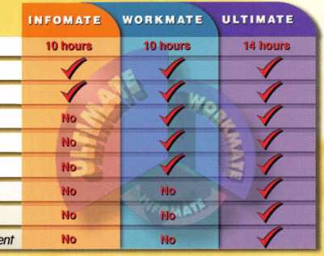

CC7V Content

CCTV Calculators

Demonstration Tool

Estimation

Drawing

Internet Enabled

Pre-Test

Quizzes

Sold in Over 50 Countries



3003 Live Oak Street  
Dallas,Texas 75204

COPYRIGHT © 1996 Security Training and Marketing Pty Ltd.  
All rights reserved ACN 057 006 541

Country

Tel: ( )

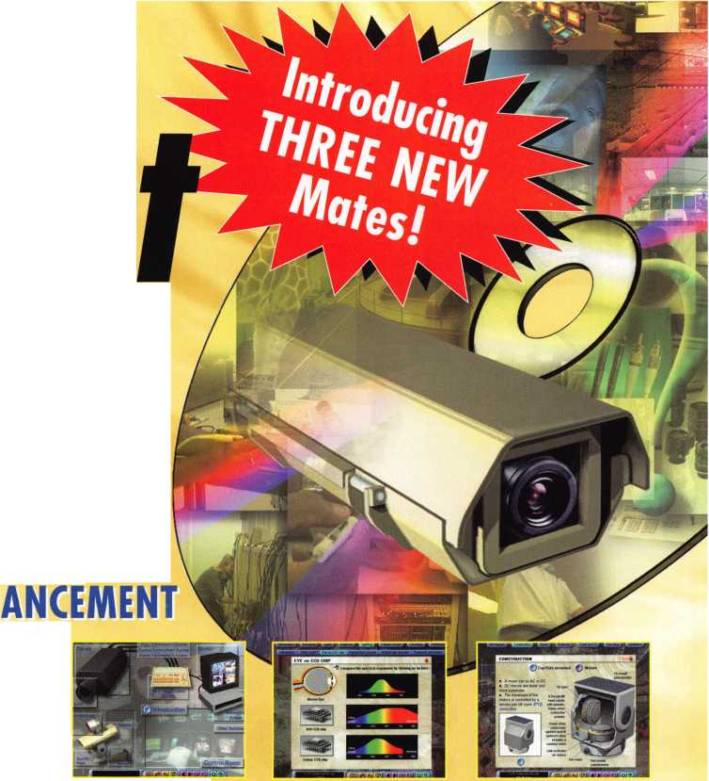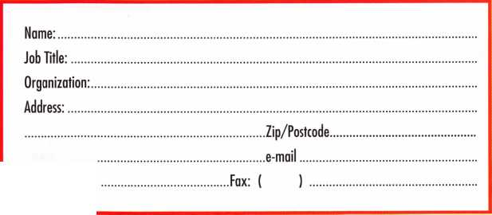

**NOV I OCT I SEPT I AUGUST I JULY I JUNE**

**upcoming**

|  |  |
| --- | --- |
| 1-2 Greater Houston Locksmith Assr Intermediate Locksmithing with CD Lipscomb, CML, CPS  979) 323-9919 or  <http://ghla>. 1 cis.com/index.htnr | 2 Greater Houston Locksmith Assn. 2 North Jersey Master Locksmiths  Swap Meet Association 8th Annual Flea Mkt.  Contact: (979) 323-9919 or Lyndhurst, NJ • 201/944-7547  <http://ghla>. 1 cis.com/index.html or 973/777-0620  >1 |
| 19 Central Florida Locksmith Assoc ation Membership Meeting (386) 775-3641 | - 20 Florida West Coast Locksmith 21 Central & Southern  Association (FWCLA) Colorado Locksmith Assn  General Meeting (303)688-4104  (727) 849-1812 |

5 Minnesota Chapter of ALOA Membership Meeting [www.locksmithnews.com](http://www.locksmithnews.com)

22-23 Greater Houston Locksmiths' Assn. Safe Penetration Party w/Dave McOmie (979) 323-9919 or <http://ghla>. 1 cis.com/index.html

3

Minnesota Chapter of ALOA Membership Meeting [www.locksmithnews.com](http://www.locksmithnews.com)

13-14 DHI Convention and Expo, Chicago, Illinois [www.dhi.org](http://www.dhi.org)

|  |  |
| --- | --- |
| 22-28 ALOA 2002 | 22-28 South Carolina Locksmith |
| (800) 532-2562 | Assn. Meeting |
| [www.aloa.org](http://www.aloa.org) | (803) 432-9008 |

17

Central Florida Locksmith Assn. Membership Meeting (386) 775-3641

7 Minnesota Chapter of ALOA 11 Membership Meeting www. locksmi th news. com



Fox Valley Chapter of ALOA 1 Oth Anniversary Foxy Lady Cruise (715) 355-5397



14-16 ISC EXPO/East Orlando, Florida siaonline.org

4 Minnesota Chapter of ALOA Membership Meeting [www.locksmithnews.com](http://www.locksmithnews.com)

14 Greater Houston Locksmith

Assn. • Auto Opening with Steve Young • (979) 323-9919 or [ditels@fbtc.net](mailto:ditels@fbtc.net)

<http://ghla>. 1 cis.com/index.htm

19 Florida West Coast Locksmith Association (FWCLA)

General Meeting (727) 849-1812

18 Florida West Coast Locksmith Association (FWCLA)

General Meeting (727) 849-1812

16 Central & Southern Colorado Locksmith Assn (303) 688-4104

]

25-29 SERLAC Trade Show Orlando, FL (800) 845-529 [www.serlac.com](http://www.serlac.com) ACE

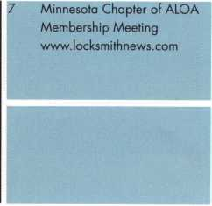

1-5 Pacific Locksmith Association Annual Convention Portland, OR 541/741-6902 [www.pla-pro.org](http://www.pla-pro.org)

3 Oregon Professional Locksmith Day Banquet • Pacific Locksmith Conference* Featured guest: Tim McMullen [www.pla-pro.org](http://www.pla-pro.org)

14-19 ACE Six-Day

Basic Locksmithing Course



L



**events**

|  |  |
| --- | --- |
| 14 PRP • Dallas, TX | 18 Mount Diablo Chapter of |
| (800) 532-ALOA (2562) | CLA Meeting |
|  | (707) 642-2661 |

|  |  |
| --- | --- |
| 23 PRP* Socorro, NM | 22-23 Florida West Coast Locksmith |
| New Mexico locksmiths Assoc. | Assoc. • Lockmasters Electronic |
| 505/266-5577 | Safe Lock Servicing with |
|  | Brian Lamb • Tampa, FL |
|  | (727) 849-1812 |

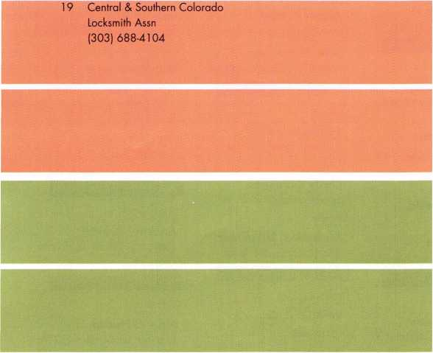

27-29 Jo-Van Distributors Inc.

2002 Annual Security Show and Educational Conference 416/752-2238 or 888/752-7210

23-27 Greater Philadelphia Locksmith 25-26 South Carolina

Association (G-PLA) Convention Locksmith Assn. Meeting

(803) 432-9009



UPCOMING PRP SITTINGS

June 14 ALOA • Dallas, TX • Ashley Manson: 800/532-2562, ext. 30

June 16 Clark Security Products • Reno, NV * Joan Emrick: 619/718-7308

June 23 New Mexico Tech Socorro • Socorro, NM • Brian Sweeney: 505/266-5577

June 14 ALOA • Dallas, TX • Ashley Manson: 800/532-2562, ext. 30

July 12 ALOA • Dallas, TX • Ashley Manson: 800/532-2562, ext. 30

July 26 ALOA • Rosemont, IL* Ashley Manson: 800/532-2562, ext. 30

Aug. 9 ALOA • Dallas, TX • Ashley Manson: 800/532-2562, ext. 30

Aug. 18 Clark Security Products • Elicott, MD • Joan Emrick: 619/718-7308

Sept. 13 ALOA • Dallas, TX • Ashley Manson: 800/532-2562, ext. 30

Sept. 22 Clark Security Products • Anaheim, CA • Joan Emrick: 619/718-7308

Oct.l 1 ALOA • Dallas, TX • Ashley Manson: 800/532-2562, ext. 30

Nov. 8 ALOA • Dallas, TX • Ashley Manson: 800/532-2562, ext. 30

Nov. 11 Crand Canyon Chapter of ALOA • Phoenix, AZ John Ilk, CRL, CPS: 602-420-2174

Dec. 13 ALOA • Dallas, TX • Ashley Manson: 800/532-2562, ext. 30

UPCOMING ACE CLASSES

June 29-30 Northern Indiana Chapter of ALOA • Fort Wayne, IN Jermey Rodocker, CPL, CPS: 219/459-1500

July 21-28 ALOA 2002 Convention • Rosemont, IL • Ashley Manson: 800/532-2562, ext. 30

Aug. 23-25 Central NY Locksmith Association • Syracuse, NY Ronald Smith, CRL: 315/658-2368

Sept. 11-13 Nutmeg Chapter of ALOA • Nutmeg, CT Dale Hobbs, CRL: 203/237-4602

Sept. 21-22 Central NY Locksmith Association • Ronald Smith, CRL: 315/658-2368

Sept. 25-27 SERLAC • Orlando, FL • Michael Belden, CRL, CPS: 904/396-2022

Oct. 14-19 Fox Valley Technical College • Appleton, Wl • Jerry Antoon: 920/735-2406 • [www.fvtc.edu](http://www.fvtc.edu)



|  |  |  |  |  |
| --- | --- | --- | --- | --- |
| AL |  | FL | Rochester Hills Middletown | VA |

Ben Williams

Sponsor: Lorry W. Williams RL, CPP

Wyoming

Robert C. Van Ee

Sponsor: Peter Sorailian CRL

MN

Apple Valley

Greg McLaughlin

Sponsor: Mark T. Hokonson CML

Jared J. Musta

Sponsor: Mark T. Hokonson CML

Little Canada

Paul M. Kostecki

Red Wing

Dale Dugstad

Sponsor: William P Noseth CRL

Joseph J. LiVigni CRL

New York

Shmuel A. Herman

Nyack

Adam R. Peel

Patchogue

John Flanagan

Sponsor: Peter Sorailian CRL

OH

Genoa

James L. Cornell

Sponsor: Mark V. Ames

Mansfield

Cindy Billheimer

Sponsor: Robert R. Turner

Shelby

Andrew J. Billheimer

Sponsor: Robert R. Turner

Birmingham

Ervin A. Van Slambrouck

Sponsor: Robert J. McCormick CRL

AZ

Phoenix

Carol A. Jacobs

Sponsor: William Lee

CA

Cathedral City

Marvin W. Nash

Sponsor: Jack Lindstrom

Concord

Robert Greathouse

El Cajon

Terry A. Logan

Sponsor: Winston E. Miller Jr, CRL

Fontana

Debby Halbert Jim Mumbauer

La Palma

Charles R. Moore Sr

Sponsor: Julie McCluney CRL

San Jose

Ronald D. Farrey, Sr.

Sponsor: C Dean Reese

Susi McCarthy

CO

Breckenridge

Greg Notarmuzi

Sponsor: Madeline L Shandy

Fort Collins

Steven E. Thompson

Sponsor: Raymond J. D'Adamo CML

Lake Worth

Salvatore Barbarello

GA

Fayetteville

James H. Cashwell

Sponsor: Harold L Hardy CRL

IA

Cedar Rapids

Donald S. Fritz

Sponsor: Harry G. Russell



Downers Grove

Larry T. Kutella Mark Kutella

Sponsor: Larry T. Kutella

East Peoria

Phillip N. Merriman

Sponsor: Scott A. Kelso

Peoria

Rafael M. Vasquez

Sponsor: Robert T. Doran CML

Westchester

Michael McGuire CRL

Sponsor: Larry T. Kutella

IN

Huntington

Dan E. Reust

Sponsor: Jim Williams CRL

Speedway

David E. Underhill

Sponsor: Jim Williams CRL

MD

Temple Hills

Jonathan Long

Ml

NJ

Irvington

Angelo Espinoza

Sponsor: Peter Sorailian CRL

Somerset

Kelly Corbett

NV

Las Vegas

William G. Montoya

Sponsor: Ernest W. Wright

Robert Press

Sponsor: James A. Nelson CRL

Binghamton

James M. Gentilini

Sponsor: William C. Ryan CRL

Brooklyn

John P. Blacie

Sponsor: Peter Sorailian CRL

Freeport

Heidi Kinhackl

Sponsor: Peter Sorailian CRL

Lancaster

Ron Gentner

Merrick

Keith Gerold

Sponsor: Wayne J. Norris Jr

PA

Holicong

William E. Croce Jr

Morrisville

Robert Rita

Philadelphia

Thomas Kline

Thorndale

Dale K. Mast

Sponsor: Keith S. Smith

PR

San Juan

Cesar Arroyo

sc

Ninety Six

Jeffrey Owens

TX

Denton

Paul A. Forgey

Sponsor: Dawn M. Forgey CRL Tyler

Buddy Morphis

Sponsor: Ralph O. Warren CML

Alexandria

Anthony A. Ortiz

Sponsor: Peter Sorailian CRL

Arlington

Joshua Lutz

Sponsor: Michael B. Groves

Salem

Dan Boadwine

Sponsor: Clyde T. Roberson CML, CPS Springfield

Tony J. Ashley

Sponsor: Paul A. Haebler CRL, CPS, OS

WA

Long Beach

Andrew R. Walls

Sponsor: William Blanchard CRL, CPS

wi

Kenosha

Mike L. Hecke

Sponsor: Christopher C. Olson CRL

Canada

Abbotsford British

Larry Runnalls



London

Darren Kilner

Sponsor: Joe J. Lee CRL

West Gram South Wal

David K. Burrows

Great Britian Laindon Essex

Sean Waterfall

Korea

Su Seong-ku Daz Ku-

Yong Ramk Jun

Sponsor: Clarence F. Galli



Bramley Tadley Hamp

Andrew Wickens

Sponsor: Ken Dale

Bristol

Joseph B. Panella

Washington

Jason C. Battle

Sponsor: Philip A. Rovenolt CPL

Bloomingdale

Lew Hitts CPS

Sponsor: Kenneth A. Griffin CML, CPS Clinton Township

Joseph F. Sykes

Sponsor: Richard J. Podgorski

These applicants are scheduled for clearance as members of ALOA. The names are published for member review and comment within 30 days of this  
Keynotes issue date, respectively, to ensure applicants meet standards of ALOA's Code of Ethics. Protests, if any, should be addressed to the Membership  
Department and must be signed. Active Membership applicants (a) have worked in the industry two or more years. Allied Membership (AL) applicants are not  
locksmiths, but work in a security-related field. Apprentice Membership (AP) applicants have worked in the industry less than two years.

Keynotes • June 2002

The original is back.

Accept no CHEAP SUBSTITUTES.

Participate in the only van and storefront contest that PAYS!

ALOA is now accepting photo entries for the all-new 2002 van and storefront contest. In reclaiming  
the old contest, we've made some great updates. Prizes will be given out to the top three winners,  
who will be announced on the show floor at ALOA 2002 in the Chicago suburb of Rosemont, IL.  
(Winners do not have to be present to claim prizes.)

All you have to do for your chance to win one of three great prizes is submit a printed picture of your  
storefront or van (complete with contact information) to the following address: ALOA Van and Storefront Contest,  
3003 Live Oak St., Dallas, TX 75204. Or, simply e-mail a high-resolution photo in JPEG format (no files over  
3 megabytes will be accepted) to: [editor@aloa.org](mailto:editor@aloa.org). (Note: Make sure to write  
"ALOA Van and Storefront contest" in the subject header of the e-mail.) Good luck and  
may the best van win! (And the best shop front too!)

Entries accepted now through July 1, 2002.  
Hurry now to be a part of the original ...

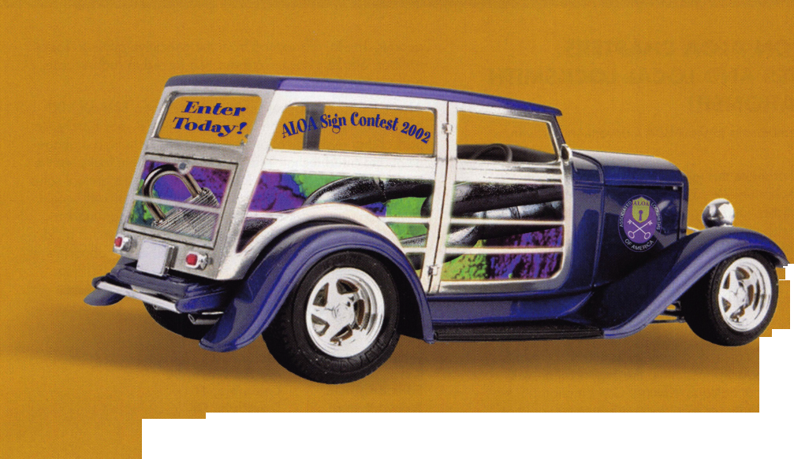

:

f

core

ATTENTION ALOA CHAPTERS, AFFILIATES AND LOCAL LOCKSMITH ASSOCIATIONS!!'

Bring your membership to the ALOA Convention and win prizes!!

In an effort to promote this year's ALOA Convention, in Rosemont, Illinois, July 22 - 28, ALOA is offering its Chapters, Affiliates, and local locksmith associations the fol­lowing reasons to join us!

* Have your Monthly Chapter/Association meeting during the Convention - well give you the space to hold it!
* Each one of your members who attend will receive an extra raffle ticket for the NEW VAN DRAWING;
* Each one of your members will get free entrance into the Tradeshow;
* For Chapters, Affiliates, and local locksmith associations that register at least 20 members, the organization will receive LAB's great Schlage/Kwikset Combination pin kit;
* The Chapter, Affiliate, or local locksmith association that registers the most members, the organization will receive a 7-day Registration Package at the 2003 Convention in Las Vegas (approx. $900 value)!!

ALOA Class Addition

Monday, July 22, 2002 8am - 5pm 112 NKL Safe Certification Class

Instructor: Lonce Ponder (NKL FireKing)

Geared toward technicians who install and service intelligent security products, this one day comprehensive training ses­sion covers the technology, installation, operation, and serv­ice of NKL's AuditLok XLV electronic cash management sys­tem for the Autobank and Intellisafe products. The course starts with a presentation of technology, applications, securi­ty, dispensing, bill validation, and integration. Students will then participate in extensive hands on operation and pro­gramming at both system and component levels. By the final certification phase of the class, students will be able to install, configure, and operate all aspects of this powerful cash control platform known as the NKL AuditLok XLV.

Best Layoff

Best Access Systems recently laid off 150 workers, effective immediately — about half at its Indianapolis headquarters — due to the recession and lingering effects of the Sept. 1 1 ter­rorist attacks.

The door-lock maker typically feels economic impacts several months later than many businesses, said Georgia Shaffalo, director of business services, and the effects hit in the first

quarter. The layoffs extend from the executive office to facto­ry floor, Shaffalo said. "We've been forced to reduce costs, and that (includes) people."

About 1,550 employees remain. A year ago Best cut 100 blue-collar workers in the first layoff of its 78-year history. As part of that reorganization, the company reshuffled manage­ment and hired technicians to service electronic locks. At the time the company said it planned to triple Best's annual sales of $150 million within five years. Most of the growth would come from deeper penetration of North American markets, particularly in university, government and commercial build­ings, it said. Best had also planned to sell its headquarters at 6161 E. 75th St. and move elsewhere in central Indiana.

New Certifications

CRLs

William Botek Kevin Bowers Silas Bright Jr. Steven Brown Pierre Burley Michael Glasser James Honickel Robert Kern Clinton Koch Joseph Livigni Andrew Maas Tony Pursley Anthony Reed Augusta Robinson Lawrence Spears John Stearns

CPLs

Christopher Melton

CPS s

Gerald Leggore

Aloha, OR  
Myrtle Beach, SC  
Columbia, SC  
Troutdale, OR  
Charlotte, NC  
Fair Lawn, NJ  
Greenvillage, NJ  
Cape May Court, NJ  
Coopersburg, PA  
Chester, NY  
Elk River, MN  
Suwanee, GA  
Hanover, PA  
Littonia, GA  
Awendaw, SC  
Minneapolis, MN

Lexington, SC

Middletown, PA

Let Us Know!

If you have an opinion to offer on ALOA, the state of the industry, or life in general, we want to know about it! Submissions to the "Mailbox" section of Keynotes are printed on a space-available basis. Write to: "Letters to the Editor"; ALOA; 3003 Live Oak Street; Dallas, TX, 75240; FAX 214/827-1810; e-mail: [editor@aloa.org](mailto:editor@aloa.org).

Need Help?

At ALOA, we want to make sure you are getting as much bang for your membership dues buck as we are able to give you. If you have had problems getting membership services, or have a question regarding member services, please con­tact Bill Gibson, exectuve director, at 800/532-2562 xl5, or e-mail: [charlie@aloa.org](mailto:charlie@aloa.org).



Keynotes • June 2002

2002 Convention and Security Expo Sponsors

ALOA would like to give special thanks to our 2002 Convention and Security Expo sponsors. Without the gener­ous donations of these companies, the ALOA show could not happen. We thank them and recognize their efforts to help our industry thrive year after year.

The "Stars and Stripes" sponsors for this year are as follows:

AMSEC KABA, KABA ILCO, KABA MAS

MAG Security  
Medeco  
STRATTEC  
Security  
Corporation

IR Security & Safety

W-LOK Corp.

The ALOA Scholarship Foundation Kickoff Party

Sponsored by IR Security and Safety Additional Contributors include:

AMSEC  
Adesco Safe  
Manufacturers  
ASSA  
Abloy

Clark Security Products Gardall Mul-T-Lock Sargent

La Gard, Inc. Sargent & Greenleaf, Inc.

Silver Sales

The ALOA Open Golf Tournament

Sponsored by Yale Security Group, Inc.

Additional Contributors include:

Lucky Line STRATTEC Security

Products Security Solutions

Corporation

Four ALOA members representing North Carolina Locksmiths on Licensing Board

The North Carolina Locksmith Licesing Board has just been formed, and four of the locksmiths appointed are active ALOA members. Congratulations to:

Laura Busse, CRL • Dennis Green, CPL • Ralph E. Fuller Thomas F. Campion, CRL

The Board consists of six locksmiths and three citizens who do not have a relationship with the locksmithing industry. The Governor, President Pro Tempore of the Senate and Speaker of the House of Representatives appointed three members each. There first job will be to write the regulations govern­ing the industry. Watch for more updates in Keynotes and on the website at [www.aloa.org](http://www.aloa.org).

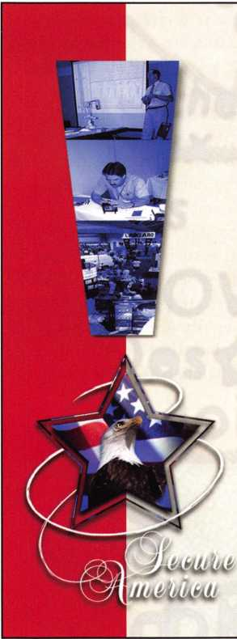

"Locksmiths Secure America"

2002 ALOA Convention and Security Expo

Here are just a few of the highlights you'll be getting at this year's show in  
Rosemont, Illinois • July 22-29, 2002:

Chicago/Rosemont - one of our industry's greatest towns in terms of locksmithing tradition, the Chicago metro area is also home to a plethora of day and nighttime activities. See a Cubs game, a Jerry Springer show or just stroll along Lake Michigan.

Kickoff Party/Live Auction - Show up, eat drink and be merry. Then bid on vastly dis­counted locksmithing equip­ment and education packages, which are the finest under the sun. How do we do it? It's all for charity - the ALOA Scholarship Foundation.

World-class Hyatt Regency O'Hare - the official host hotel for the ALOA 2002

Convention. It is conveniently located adjacent to the Donald E. Stephens Convention Center and includes complimentary transportation to and from Chicago O'Hare International Airport and the commuter train to downtown Chicago is just minutes away. The hotel also features a fully equipped healthclub, with an indoor swimming pool, and a red­wood sauna for your enjoy­ment. Need we say more?

Tours - our variety of tours this year in the "Windy City" the most highly rated tours in the area, and ones that your spouse or guest can enjoy while you attend classes (Choose from "Highlights of Chicago," "Chicago

Architectural River Cruise" and "The North Shore and Botanical Gardens.")

The ALOA Open Golf Tournament at the Chicago's posh Chalet Hills Golf Club. Benefiting the ALOA Scholarship Foundation (tax deductible), the tournament includes transportation, green fees, golf cart, beverages throughout the course, lunch and prizes for all players.

ALOA Dinner Event - Plan on being part of this event reminis­cent of the patriotic "USO" shows of the past. A truly mem­orable dining and entertain­ment experience is planned for you in the Grand Ballroom of the Hyatt Regency O'Hare.

Note: Register BEFORE JUNE 21 for huge discounts!!  
1-800-532-2562 • [www.aloa.org](http://www.aloa.org)

Keynotes • June 2002

High Security:

ASSA Lock Cylinder Upgrades

By Sal Dulcamaro, CML

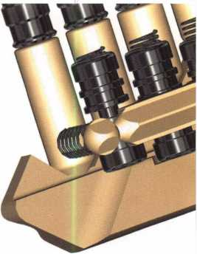

full-fledged key control, a company with an expiring patent will usually have a new patented product waiting in the wings as its replacement.

For patented key control prod-

ucts, the expiration  
of the controlling  
patent is a signifi-  
cant event. There is  
typically a premium  
price paid for  
patented key con-  
trol. Saying that no  
third party compa-  
ny is currently mak-

ing key blanks to fit

their product line is not the same as  
saying that there would be legal reper-  
cussions if someone did. To maintain

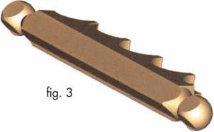

ASSA is one lock company that recently had to deal with those issues. Figure i is a graphic illustration of the ASSA Twin 6000 high security lock cylinder and its key. It is in cutaway view to partially show the more con­ventional pin chambers and the side- bar at the left side of the cylinder plug that makes it “high security. “ What looks like a long red pin just to the left

of the pin chamber closest to the lock face is a hardened pin, which was added to increase drill resistance (besides its pick resistance). Having resistance to both manipulation and physical force are among the standards required to meet a UL437 rating as high security If you look closely, you may see the actual pin chamber just behind it.

ASSA originates in Sweden and has slightly different reference points compared to most American locks.

For ASSA, key cut and pin chamber positions are referenced from tip to bow rather than bow to tip, even though ASSA has a shoulder-stopped key. Tip to bow reference is not totally out of the ordinary. After all, most Best style/ Small Format Interchangeable Core (SFIC) keys are referenced as such. Those are tipped- stopped keys, however, and shoulder- stopped keys are rarely referenced in that manner. By ASSA standards, that hardened pin is between the fifth and sixth pin chambers (from the back of the lock).

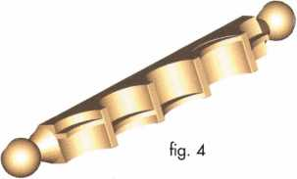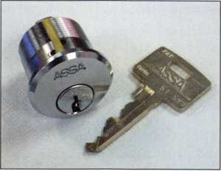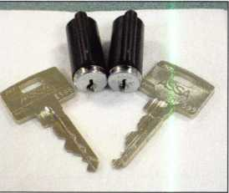

photo 1

photo 2

12

Keynotes • June 2002

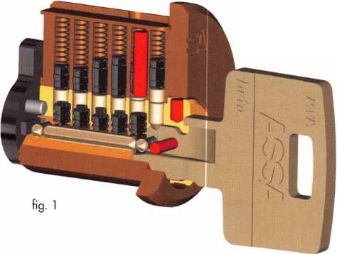

Closer  
detail of  
the ASSA  
Twin  
6000 key  
and its  
interac-  
tion with  
the vari-  
ous tum-  
blers can

be found in figure 2. There are two  
independent sets of tumblers in the  
lock cylinder, and likewise, two inde-  
pendent sets of tumbler cuts on the  
key to position those tumblers for  
unlocking. The conventional type pins  
fill six pin chambers, while the side  
pins (which interact with the sidebar)  
number only five, with their pin cham-  
bers centered between the more con-  
ventional pins. The side pins are  
somewhat spool shaped with wide flats  
on the bottom. Milled cuts on the left  
side of the key (of varied heights) lift  
the side pins to the proper positions  
to unlock the sidebar component.

A number of different brand high security locks work on similar princi­ples with sidebars. What makes ASSA unique is that the side pins are all identical to each other, but the indi­vidual dealer sidebars are all different from each other. Figure 3 shows the wedge shaped outside surface (which locks into a slot in the lock cylinder shell) of an ASSA sidebar which does not vary from one dealer to the next.

It is the inside surface where the varia­tion takes place, as shown in figure 4.

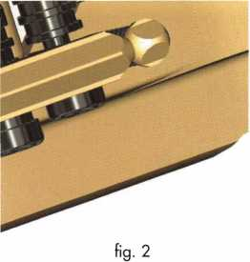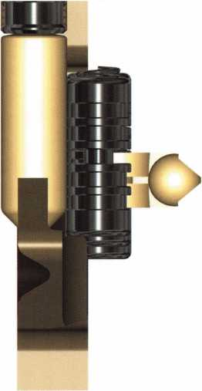

Five individually positioned ridges  
along the length of the sidebar require  
each side pin to be lifted to various

heights so the deep slot in the  
middle of the spool-shaped pin  
will fit over each ridge. Figure 5  
shows a snapshot of a single  
conventional pin chamber and  
a single side pin chamber with  
the corresponding cuts of the  
ASSA key positioning each tum-

bler to unlock. This is a view from  
the key tip. The conventional pin

and key cut work the same as in virtu-  
ally any pin tumbler lock cylinder. A  
wide side-milled cut lifts the spool-  
shaped side pin to position its deep  
slot over the sidebar ridge in its pin  
chamber position. If the correct oper-  
ating key is inserted, the conventional  
pins will all split at the shear line and  
the side pins will line up with their  
deep slots positioned in line with all  
the sidebar ridges.

The Patent Expiration

The patent for the ASSA Twin 6000 high security/ key control product line had recently expired, but a few years prior, ASSA had introduced its new patented product line: V-10. Although no key blank manufacturer (to my knowledge) is manufacturing key blanks that will fit into Twin 6000 lock cylinders at the current time, the controlling patent has expired. If you were selling a new high security system to a customer where patented key con­trol is desired, it would be prudent to sell V-10 over the older Twin 6000. From the customer’s vantage point,

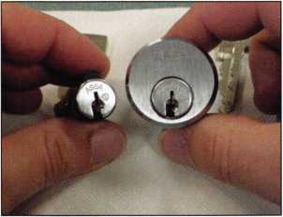

photo 3

photo 4

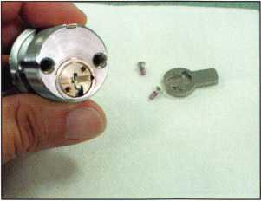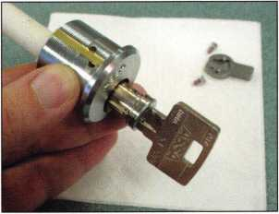

photo 5

Keynotes • June 2002

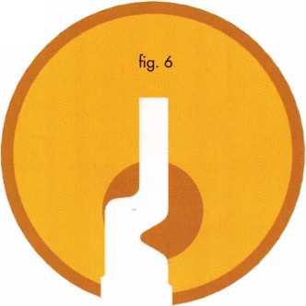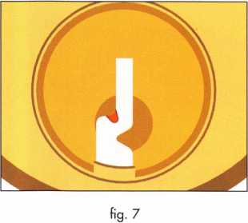

the cost would be virtually the same and a current utility patent is in force to protect key control. If you already have customers using the Twin 6000 system, it would be a smart thing to notify them that the patent that pro­tects their key control has expired. After you explain the legal and practi-

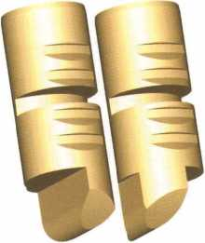

fig. 8

cal concerns, they can tell you if they will stay as they are for now or whether they prefer to upgrade.

The cost of upgrading your customer may not be as high as you might oth­erwise imagine. There is a very high level of backward compatibility between the new patented V-10 system and the (now patent expired) Twin 6000 system. Beside that, ASSA has recently introduced a new patent­ed key control product line called Twin Exclusive with strong similarities to the Twin 6000 product, but sharing newly patented features of V-10.

You can upgrade to either V-10 or Twin Exclusive without having to

replace entire lock cylinders, which will substantially reduce upgrade costs.

Variations in the New Patented Product Lines



Among the newly patented  
features of V-10 are a severe-  
ly angled keyway milling (and  
a matching severe angle pro-  
file in the keyway broaching)  
and newly designed side pins  
that create some interesting  
new master keying capabili-  
ties. Twin Exclusive only  
shares the severe angle pat-

tern in its key and keyway broaching.  
The most recent Twin 6000 keyway is  
shown in figure 6. The severe angle of  
the Twin Exclusive can be seen (by  
comparison) in its keyway broaching  
pattern shown in figure 7. The V-10  
product shares a similar deep angle  
profile as part of its keyway. There are  
additional features, though, that dis-  
tinguish V-10. Figure 8 shows both a  
right and left V-10 side pin. The Twin  
6000 spool-shaped side pins are made  
of stainless steel, while the V-10 side  
pins are made of nickel silver.

The mechanical interaction of a V-10 key and tumblers is shown in figure 9. The bottom tips of the V-10 side pins are narrower and fit into a narrower side bit milling on the key itself. Because they must maintain left or right hand contact with the side bit milling on the key, they are somewhat oval in shape (as are the side pin chamber holes) to prevent rotation of

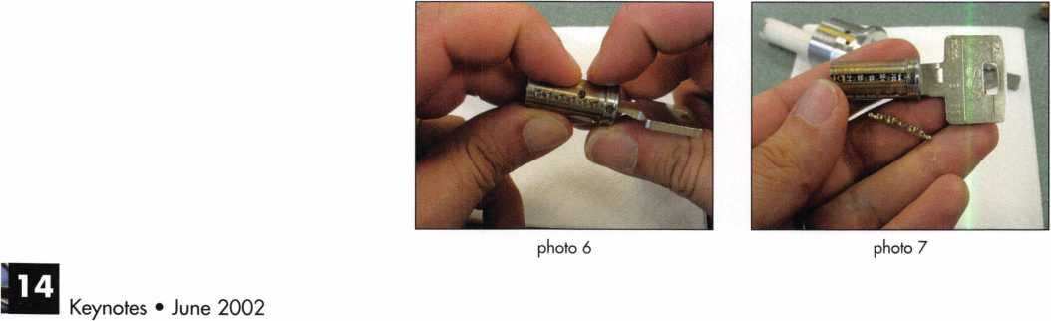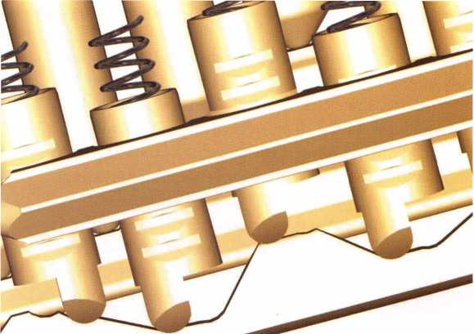

the side pins. The mechanical interaction of a V-io key and all of the various tumblers can be seen in figure 9. A single conventional pin and side pin are isolated in a snap shot shown in figure 10. Just like the Twin 6000, when the cor­rect operating key is inserted, all the conventional pins split at the shear line and the slots of the side pins line up with the individual ridges of the side- bar. Upon key rotation, the sidebar will be forced inward into the slots of the sidebar, and the plug will turn. Figure 11 is the V-10 keyway It has a similar severe angle groove to the Twin Exclusive keyway shown earlier, but the actual keyway pro­file is different.

Upgrading a Twin 6000 Lock Cylinder

The basic service procedure for upgrading the older cylinder is similar, but the slight difference in component parts may affect the specific process. Photograph i shows a Twin 6000 mortise cylinder and its operating key. To upgrade the lock cylinder, you only need to replace the cylinder plug and any different tumblers and springs within the plug. The replacement plugs are available pre­

loaded, or completely empty (where you will need to transfer or replace side pins and springs). Both an ASSA Twin Exclusive (left) and V-10 (right) plug assembly are shown in photograph 2.

Photograph 3 shows a Twin 6000 mortise cylinder and a Twin Exclusive plug for upgrading it. Except for the more restrictive keyway, the Twin Exclusive plug will share common mechani­cal components with the already assembled Twin 6000 plug. The two cam screws and cam have been removed in photograph 4, and the operating key has been inserted. After rotating the plug clockwise, I proceeded to follow out the plug as in photograph 5.

For many years, it has been my practice to always rotate the plug slightly before following it out for

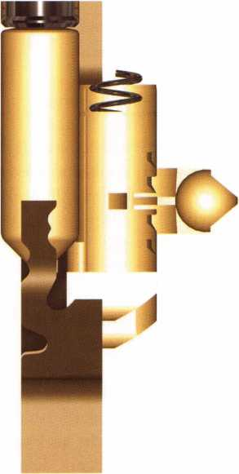

fig. 10

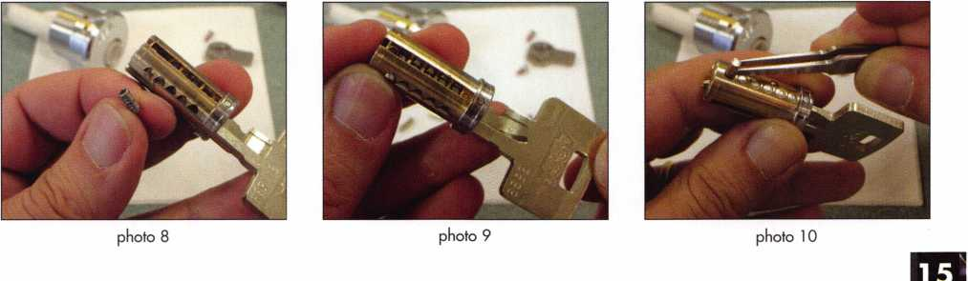

Keynotes • June 2002

service. In the old days, it didn’t matter whether the  
rotation was clockwise or counterclockwise, just so  
long as it was rotated. The purpose for doing it was  
to eliminate the possibility of trapping the plug by  
having a top pin drop into an empty pin chamber.

By keeping the upper and lower pin chambers  
misaligned, a top pin could not fall into a lower  
pin chamber. The practice served me

well until a mishap with an ASSA  
lock cylinder, many years ago,  
forced me to alter my service

procedure.

One day, after rotating an  
ASSA plug counterclock-  
wise, I proceeded to use  
a plug follower to follow  
out the plug in order to  
service the lock. The  
plug moved out a very  
short distance before sud-  
denly trapping. My first  
instinct was to think that  
I had mistakenly rotated the

plug back to 12 o’clock. I figured  
that a top pin must have dropped

into an empty (or partially empty) bottom  
pin chamber. When I looked at the face of plug,  
it was not at 12 o’clock. Something else must have

trapped it, but what? After much consternation, I was  
forced to remove the slide cover at the top of the lock  
cylinder shell and remove all the pins from the top of  
the cylinder. After removing the plug, I discovered  
the culprit. It was something that I had half recog-  
nized before, but never considered a possible prob-  
lem, until my mishap.

If you look at photograph 6, you will see a hardened pin positioned between the fourth and fifth pin chambers (counted from the back of the plug), just between the tips of my fingers. The hardened pin is pushed below the surface of the plug, and so there is a

small gap at the top creating the appearance of a par-  
tially empty pin chamber. It never had crossed my  
mind before, since that hole’s diameter was consider-  
ably smaller than the diameters of the pin chambers.  
What I hadn’t accounted for was that standard ASSA  
top pins (or driver pins) are spool-type pins for added  
pick resistance. The problem wasn’t that it was a

spool-type driver pin. It was the diameter of the

driver pin on that bottom spooled surface.  
The diameter was smaller there com-

pared to the full diameter of the pin.  
And it happened to be just small

enough to fit into that gap on  
top of the hardened pin. From  
that point forward, I’ve made  
it a point to always rotate  
plugs clockwise rather than  
counterclockwise, before fol-  
lowing them out for servicing.

Photograph 7 shows the  
Twin 6000 plug removed. The

sidebar comes out very easily, so be  
careful to hold the sidebar in place

while removing the plug to avoid losing  
the sidebar springs. The sidebar is one

component that is common to all versions of  
ASSA high security lock cylinders. There is not a dif-  
ferent version sidebar for other version plugs. The  
springs are another story. They will be discussed later.  
If you have a completely empty Twin Exclusive plug,  
you will need to transfer all parts from the Twin 6000  
plug to it. That includes the sidebar, all springs and  
all tumblers. For my example here, I am leaving the  
conventional pin chamber tumblers as is and the key  
cuts for the Twin Exclusive key will be the same as  
the Twin 6000 key. Since the Twin Exclusive keyway  
broaching is more restrictive, the original Twin 6000  
key will not be able to operate the lock (as the key  
will not even enter the keyway).

photo 11

photo 12

photo 13

Keynotes • June 2002

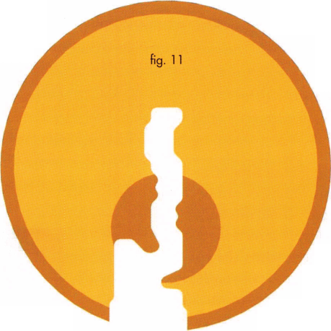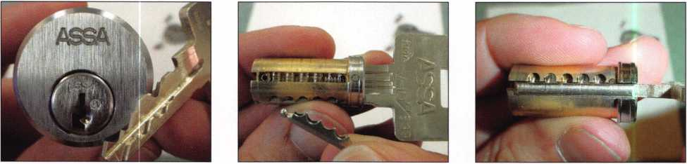

Photograph 8 shows the key slightly withdrawn from the keyway to release one of the side pins. The side pin spring has partially descended. You will need to remove all five side pins and matching side pin springs and transfer them to the new plug. The final side pin is being loaded into the new Twin Exclusive plug, in photograph 9. A key must always remain within the plug when it is removed from the shell, or the side pins will come back out again.

Since I am keeping the same cut pattern for the con­ventional cut part of the key, I transfer the bottom pins into the new plug in photograph 10. After that I would replace the same sidebar springs and sidebar. Before installing the new plug, push the sidebar inward so the plug can be inserted in a slightly clock­wise-rotated position. The Twin Exclusive plug has been successfully transferred in photograph 11. If I had intended to use a key with a different cut pattern, I would have loaded different bottom pins, but I would also have to switch the top pins. ASSA lock cylinders use approximately even pin stacks, so differ­ent length bottom pins would likely require a differ­ent size top pin.

The upgrade process when using a V-10 plug is mostly the same with a few minor modifications. Photograph 12 shows a V-10 plug with the sidebar removed. The recess for the sidebar spring is more shallow and requires a sidebar spring with lighter tension. Do not use a Twin 6000 sidebar spring (which is the same for Twin Exclusive) when installing a V-10 plug. A bottom view of the V-10 plug, in photograph 13, shows an additional hardened pin just to the right of the fifth side pin chamber (referenced from the back of the plug). You can also see that all the side pins are left side pins. V-10 plugs and cylinders will typically come that way unless master keying is to be accomplished with the side pins. Then you would see various pat­terns of left and right side pins.

If you ordered a V-10 plug without side pins, you would need to load them manually as in photograph

14. Be careful not to use Twin 6000 side pin springs. Beside keyway broaching patterns, the component differences between V-10 and Twin 6000 (Twin Exclusive uses Twin 6000 components except for plug and keys) are the side pins, side pin springs and sidebar springs. Do not mix and match between those components or you may cause a malfunction.

Other ASSA Lock Cylinders

Plug conversion can be accomplished through virtual­ly the entire ASSA product line, so long as you match the correct replacement plug to lock cylinder you have. One of the newer ASSA products is the cam lock shown in photograph 15. It has already been con­verted to V-10. Take note that the plug is full diame­ter. To maintain the small sized lock body, the upper pin chamber is considerably smaller than full size commercial lock cylinders. As a consequence, every top pin is specifically matched to a specific bottom pin size or bottom/master pin stack. If you are keep­ing the key cuts the same, the top pins will have already been accounted for, and you can just swap out the plugs as indicated before. Photograph 16 shows two cam lock plugs that are preloaded with side pins and side pin tumbler springs. Little plastic holders keep all the parts from coming out. If you intend to rekey the conventional type pins, you will need to remove and replace the top pins so they match properly.

ASSA has designed a smart and easy way to upgrade current (expired patent) product. For more informa­tion, contact ASSA at 800/235-7482. You can find them online at: www. assalock. com

I will leave you in suspense here until part two (next month), when we will apply that information when we learn how to pick one pin at a time. If you wish to contact me, you can go to my web site at <http://home.earthlink.net/dockwriter> . Look for the link to “Tech Article Addendum” and click on it. Updates and corrections are posted there, plus there is an e-mail link if you wish to contact me. Q

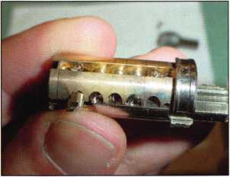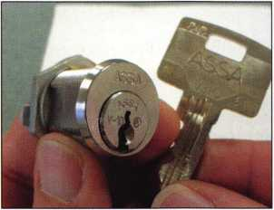

photo 14

photo 15

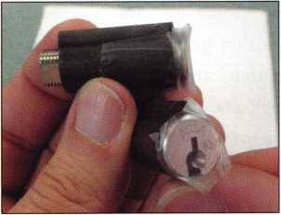

photo 16

Keynotes • June 2002

Medeco’s 20-20000 Retrofit Cylinder

By Dale L. Bowman, CRL

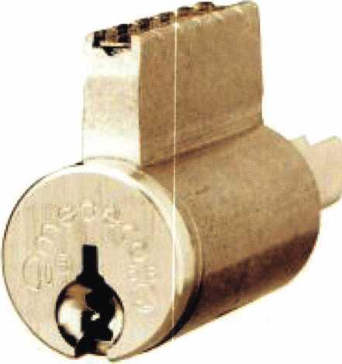

Medeco High Security Locks is a company known for various high security key control retrofit capabilities. From mortise cylinders to 26-bit Weigand base access control readers, a Medeco cylinder or access control device can be supplied for virtually any product or door out there.

Most of Medeco’s retrofit cylinders were designed using the original manufacturer’s cylinder or hardware specifi­cations. Medeco realized that it is not practical or cost effective for the locksmith to stock all the cylinders for the various manufacturer’s lockset designs. However, the potential issue a locksmith faces by not stocking these cylinders could be the loss of a customer, or the revenue from a sale you could not complete because of inventory issues.

Medeco’s solution to this problem is the development of a cylinder that can be used to retrofit a large number of various locksets. By creating a universal body type, and supplementing the retrofit capabilities by inter­

changing tailpieces, Medeco can provide one cylinder to retrofit a majority of the locksets on the market today. Medeco’s 20-20000 retrofit cylinder is designed to help reduce your inventory stocking levels as well as to keep you from missing a potential sale because of cylinder availability.

This article will identify the features, benefits, and retrofit capabilities of using the Medeco 20-20000 retrofit cylinder.

Features

The 20-20000 cylinder is a 6-pin, key-in-knob or key-in lever type cylinder. The 20-20000 cylinder is available in the Original, Biaxial, and KeyMark product lines It offers more retrofit ability and allows the locksmith to stock only one type of cylinder to meet most of their customers’ high security and key control needs. As most of you can attest, maintaining high inventory levels or stocking requirements is expensive, impractical and usu­ally an inconvenience. The only item(s) the locksmith will need to stock, including (of course) the cylinder, is a variety of inexpensive tailpieces or drivers. The tail­pieces and the various respective manufacturers’ lock- sets they work with will be identified at little later.

The 20-20000 can be implemented into an existing Medeco master key system and/or keyed alike to a group of cylinders without any limitations. The same keying/pinning specifications are used for the 20-20000 in each of the three Medeco product lines respectively.

Design

The 20-20000 cylinder is virtually identical to other key-in-knob or key-in-lever cylinders manufactured by Medeco. In the Medeco Original and Medeco Biaxial product lines, the plug face has three hardened steel

**8**

Keynotes • June 2002

rods at the 12 o’clock position to protect the tumbler pins. It also has an additional steel rod and steel ball bearing at the 3 o’clock position to protect the sidebar from drilling attacks. The top pins are made of hard­ened steel to offer addi­tional resistance against drilling. Hardened steel rods inserted through the bottom pins also help to provide drill resistance to the cylin­der. Medeco’s patented dual locking principle of elevating and rotating pins makes the cylinder virtually pick proof.

A utility patent that ensures strict key con­trol is used to protect the Biaxial product and keyways.

The KeyMark version of the 20-20000 cylinder incorporates a patent- protected, unique key­way shape design to help prevent picking attacks as well as other common cylinder attacks via the keyway. The 20-20000 cylinder for KeyMark does not incorporate the same dual locking principle incorporated in the Medeco Original and

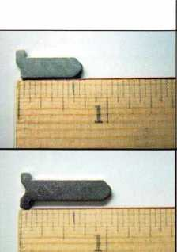

CYLINDER/TAILPIECE

•20-20000 cylinder •CT-Y49 tailpiece

**RETROFIT**

•20-20000 cylinder •CT-Y52 tailpiece

* Schlage "D" & "AL" series levers
* LSDALH1000 Knobs

Schlage "D" series knobs

Schlage "A" series knobs (excluding Orbit Trim)

* 20-20000 cylinder
* CT-Y53

Schlage "A" series knobs (Orbit Trim Only)

I



1 20-20000 cylinder 1 CT-Y54 tailpiece

—

in

Falcon "S" series knobs (excluding Hana-Gala Trim)



1 20-20000 cylinder 1 CT-Y57 tailpiece

Yale AU5400 Levers, Augusta Trim (Prior to 1990)

ii

1 20-20000 cylinder  
CT-Y58 tailpiece

Falcon "S" series knob (Flana-Gala Trim Only)

**ii**

—

S M Hill

■

-

- ■ - . '



1 20-20000 cylinder 1 CT-Y68 tailpiece

Falcon "X" series knob (excluding Hana-Gala Trim)

1!

! 4

.i os

1 20-20000 cylinder 1 CT-Y69 tailpiece

Lockwood Knob Lockset

: i

1 20-20000 cylinder • CT-Y70

Arrow "M" series knob (excluding Ball Trim) Must also use spacer number CP-160321 Sargent 6 Line knob

LSDA 100P knob (Plymouth Trim Only)



Keynotes • June 2002

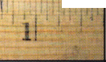

**20-200V2 20-200V1 20-200V0 20-20097 20-20078 20-20074 20-20073 20-20072 20-20071**

|  |  |  |
| --- | --- | --- |
|  | CYLINDER/TAILPIECE | RETROFIT |
|  | * 20-20000 cylinder * CT-Y71 tailpiece | • Falxon "X" series knob (Hana-Gala Trim Only  Must also use spacer number CP-160311 |
| ™ k THTTT  Pi ■ d |
| 1 11 |
|  | * 20-20000 cylinder * CT-Y72 tailpiece | • Falcon "X" series lever (Discontinued by  Falcon but still exists in the field) |
| i ■ ii': " |
| ii_ | * 20-20000 cylinder * CT-Y73 tailpiece | * Arrow "M" series knob • LSDA 100B Knob (Ball   (Ball Trim Only) Trim Only)  Must also use spacer number CP-170321   * Sargent 6 Line Knob |
| ! li' / r |
| ¥ ... | * 20-20000 cylinder * CT-Y74 tailpiece | • Schlage 45-101  Padlock |
| 1 ’ 11 ■- 4 |
|  | * 20-20000 cylinder * CT-Y78 tailpiece | • LSDA LX1000 |
| 1 ii |
| * | * 20-20000 cylinder * CT-Y97 tailpiece | • Schlage "S" series levers |
|  | * 20-20000 cylinder * CT-V00 tailpiece | * Marks 190S "Survivor Communicating (ANSI   Series" Classroom 80), Classroom Intruder  Function Function and   * Medeco Embassy 18 or Communicating   19 Series Lever Locksets, • Medeco Embassy 24 or  Functions include, 25 Series Knob Locksets  Classroom, Vestibule, Classroom Function Only |
| i li: i ' |
|  | -20-20000 cylinder -CT-V01 tailpiece | * Marks 190AB "Survivor Unlocked, and Institution   Series", Entrance Function • Medeco Embassy 24 or 25   * Medeco Embassy 18 or 19 Series Knob Locksets-All knob   Series Lever Locksets functions except Classroom  Functions include, Entrance, • Mas Hamilton Power Levers  Storeroom, Electronically • Alarm Lock - Trilogy Series T1,  Locked, Electronically T2, & T3 |
| —r" .. |
| t ' li ' ^ ■ 2l | -20-20000 cylinder -CT-V02 tailpiece | • PDQ SP Lever |

Medeco Biaxial design, but  
is an outstanding alternative  
key control cylinder, economi-  
cally priced to meet any cost  
objections your customer may  
have regarding high security  
cylinders.

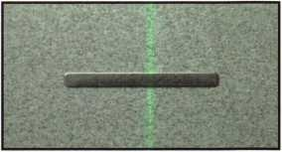

figure 1

A stainless steel pin chamber  
cover (Figure i), which is  
staked in place, is used to  
contain each pin stack in its  
respective pin chamber and  
the cylinder incorporates a  
rigid plug retainer design,  
which will be required for  
most knobs or levers on the  
market. The plug retainer  
has a cross-shaped design  
that allows many different  
tailpiece designs to work with  
the lockset or hardware you  
are retrofitting (Figure 2).

The plug retainer is held into  
place with two screws that are  
located at the 2 and 7 o’clock  
positions (Figure 3).

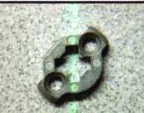

—.

figure 2

Keynotes • June 2002

CYLINDER/TAILPIECE

**RETROFIT**

|  |  |  |
| --- | --- | --- |
| Si  1 1! 2!' | * 20-20000 cylinder * CT-V03 tailpiece | • Falcon "T" series levers |
| 1 if 2i | * 20-20000 cylinder * CT-V19 tailpiece | • Corbin Russwin  CL3900 Lever |
| % |  | * Master Padlock, 6621, available from American)   6627, 6842, 7042 3600, 3700, 3800   * Medeco System Series • Schlage PL1002 Padlock   Padlocks (Requires special driver,   * American Padlocks available from American)   (Requires special driver, |

w/CP-100300 adapter/driver

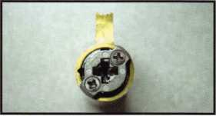

figure 3

Tailpieces

As stated earlier, the 20-20000 cylinder has the capability of utilizing many different styles of tailpieces to retrofit a majority of the locksets on the market today The 20-20000 cylinder can be ordered with a single tailpiece design to retrofit one specific application, or it can be order with a tailpiece kit to retrofit a larger range of locksets. Tailpiece kits, for use with the 20-20000 cylinder, can be supplied for the following manufacturers’ locksets:

* Arrow
* Falcon
* Schlage
* LSDA
* Sargent

Part Numbering System for the 20-20000 Cylinder

The individual tailpiece or tailpiece kit can be deter­mined by decoding the complete part number shown in the Medeco price book or product catalog. This chart should help you determine the correct tailpiece you need in order to retrofit particular locksets with the Medeco 20-20000 cylinder.

As you can see, the Medeco 20-20000 cylinder illus­trates the vast retrofit capabilities Medeco cylinders can provide to you and your customer. By using the Medeco 20-20000 retrofit cylinder, virtually all of your retrofit needs can be met. No longer will you miss out on an opportunity to provide your customer with a conven­ient, high security or key control solution to meet their needs of providing secure access to their homes or offices. Tour customers will also appreciate the fact that you can supply them with a high security or key control cylinder without the added cost of replacing the entire piece of hardware.

If you would like more information on the Medeco 20- 20000 cylinder or tailpieces, please feel free to contact your Medeco Sales Representative or contact the facto­ry direct toll free at 800/548-8472. Q

Keynotes • June 2002



The English Hockey Puck

by Greg Perry, CML, CPS

That was my first thought upon seeing this lock:

It looks like a hockey puck or an AMERICAN  
Lock 2000 padlock. What would I find inside the  
round case? I was eager to find out. This particular  
unit is mounted on the outside of a building on a  
Navy base nearby and is used to lock the door of  
a key box. It had not been used for several months  
and with the dirt and dust blowing about the  
Mojave Desert, it didn’t want to open. The base  
locksmith coaxed it open and brought it back to  
his shop. After getting it open, he called and asked  
if I wanted to see it. He gave me dialing instruc-  
tions: 5 times right, 4 times left, 3 times right,

2 times left to “o” and 1 time right to the stop.

This sounds like a 4 wheel lock? My first thought  
was that we had a forbidden zone problem, but he  
told me only the first three numbers are change-  
able. I took it back to my shop for disassembly and  
a little research.

My own library had nothing on this particular lock.  
I posted on the SAVTA web site and received a  
couple of responses from our overseas members.  
This is the lock required by the British  
Government for locking up classified information,  
the same way a Mas-Hamilton X-07 or X-08 lock  
is required by the U.S. government. One member  
sent me a copy of an article in the June 1987 issue  
of Safe and Vault Technology titled, “Chatwood  
Who? Chubb now owns Chatwood.” This article  
provided some additional information regarding  
this lock. The distribution and service of these  
locks is strictly controlled by the British govern-  
ment preventing most of us from ever seeing one  
of these locks. The name “Manifoil,” according to  
the article, is derived from “manipulation” and  
“foil.” In other words, it means the lock foils  
manipulation attempts.

Keynotes • June 2002

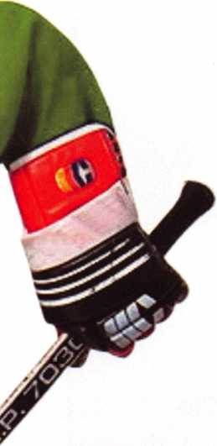

Looking at photo i, we see the dial and the  
key drop slot. The drop slot is actually a mini  
rotary hopper. Slide the key in and the drum  
turns allowing the key to drop into the box.  
The center of the dial reads, “Mark IV  
Manifoil.” The change index is eight numbers  
to the left of the opening index. Opening the  
door, we see the “hockey puck” body in  
photo 2. A raised, spring-loaded cover goes  
over the change key hole. Moving this cover  
is somewhat difficult, effectively preventing  
top or side drill and scope of the change key  
hole. The aluminum drum above the lock is  
the rotary hopper. Photo 3 shows a side view  
of the drop area of the hopper. Looking  
inside the cover in photo 4 shows the bolt  
catch that prevents the back cover from  
being removed, unless the bolt is retracted.  
The inside of the lock before we disassemble  
it is seen in photo 5. The bolt, lever and top  
half of the drive cam are removed in photo 6.  
This gives a good view of the two roller  
fences used to help foil manipulation. They  
act like a false gate might on a wheel or drive

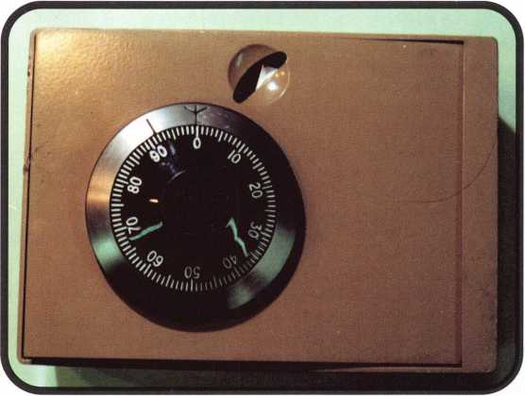

photo 1

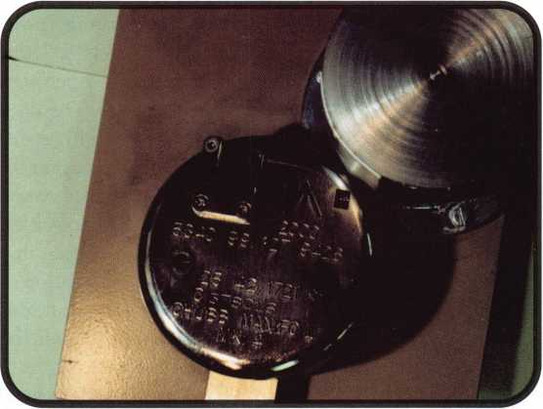

photo 2

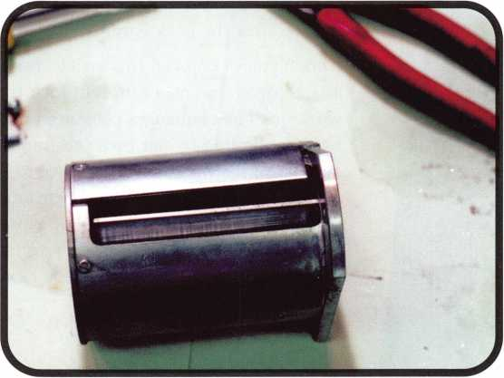

photo 3

Keynotes • June 2002

and the lower half of  
the drive cam removed.

Why a lead shroud?

This prevents X-raying  
the wheels to determine  
the combination. This shroud

can be seen in photo 8. All the  
parts are laid out in photo 9, the

wheels, flies and spacing washers  
look similar to the old S&G wheel  
packs with a spacing washer between  
the wheels and the flies. The under-  
side of the dial also has a brass disk  
with false gates cut into it again to  
aid in preventing a successful X-ray

reading of the wheels. The lower half  
of the drive cam and fly are seen in  
photo 10. Part of the manipulation  
resistance is gained with this split cam  
arrangement. It’s also why the fourth  
number of the combination is “o.”  
Changing the hand of the lock to vertical  
up or down would change this number  
accordingly. The lock is back together and  
the bolt retracted in photo 11 ready for  
service after the back is reinstalled.

I hope you’ve enjoyed this article as much as I enjoyed finding a different lock to work on. The challenges presented in our field are limited by our own self-imposed restrictions. I’ve found experience to be my best teacher. Going to conventions and classes expands my realm of experi­ence. It gives me the confidence to tackle some these unusual jobs. See you next time...[l

/ \

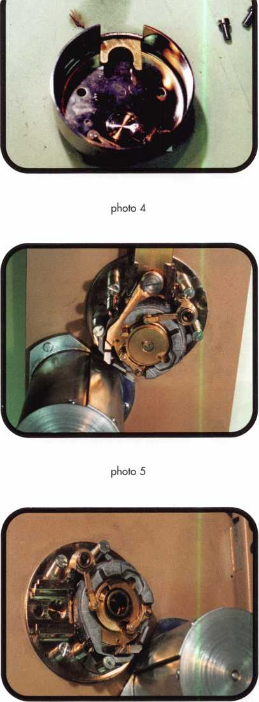

photo 6



Keynotes • June 2002

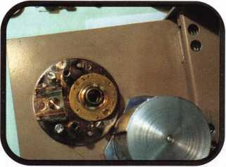

photo 7

photo 8

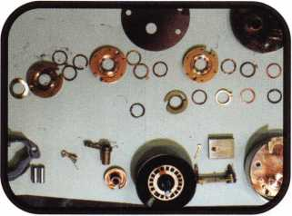

photo 9

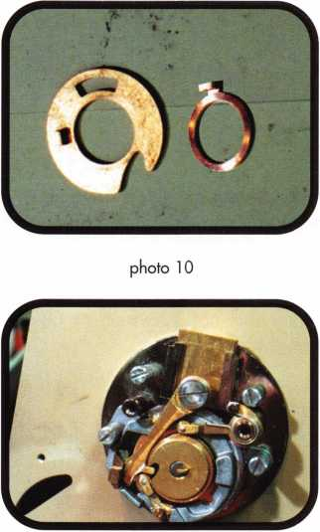

photo 11

Don’t Stay a Secret!

ALOA Members - we want to tell customers

all over the world about you. Help us by filling out  
a simple questionnaire for our all-new, expanded web  
search engine for members of the general public seeking  
locksmith services. The new search engine is designed:

* To provide potential consumers more specific infor­mation about ALOA members and the services you provide.
* As a base of specific information regarding a mem­ber's business, only those who provide information will be included in this new Locksmith Business Search area.
* The search will be updated by members who submit specific change instructions. This info will not be linked to their individual membership records.

More information about you will be going to future  
customers as a result of you filling out this simple form.

Go to [www.aloa.org](http://www.aloa.org)

or simply call us at 800/532-2562 for more info

Keynotes • June 2002

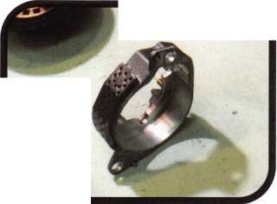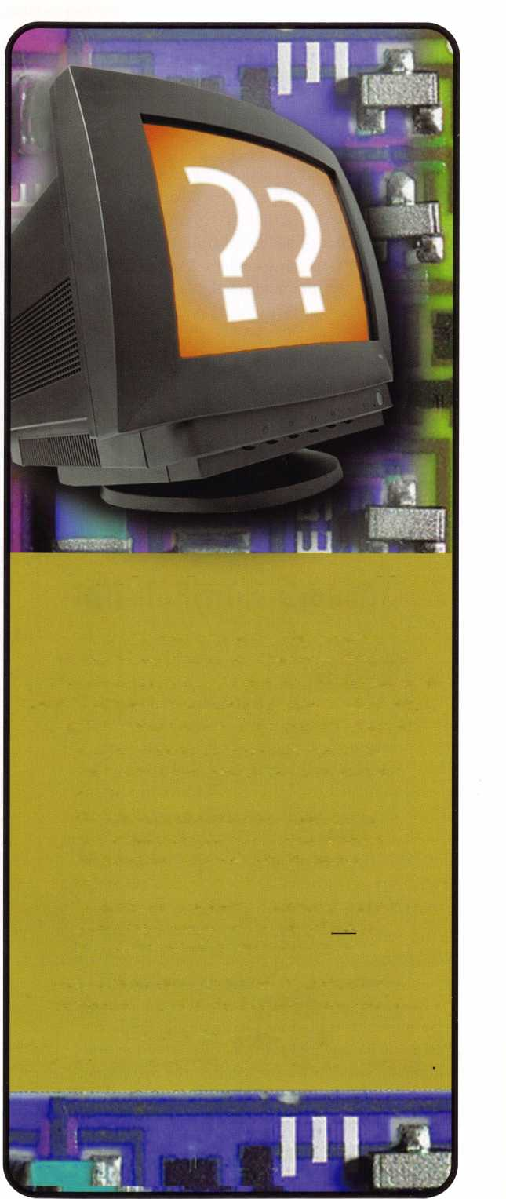

Auto High Security: It’s a Brave New World

By Tom Seroogy

It Seems that every day the locksmith wakes up to another chapter in the “Brave New World” of next generation auto lock technology Over the years, auto­motive security has transitioned from the dash to the column, to VATS, to transponders. I suspect that in a short time, well be opening small, plasma-driven, pod-shaped hovercraft for pseudo-nuclear families named “Jetson.”

Today, due to proliferating changes, many locksmiths have already been frustrated right out of doing auto­motive work. And while those brave few that remain are doing quite well, the future of automotive lock- smithing rarely includes a sunny forecast. Still, there seems to be a few bright spots on the way

Until recently, the only tools available for producing or generating new keys for a transponder-equipped vehicle were original equipment diagnostic tools. Two of the most common, and the only models openly available to the locksmith market are the Chrysler Diagnostic And Reprogramming Tool (DART) and the Ford New Generation STAR (NGS, available through Hickok Inc.).

There are some companies (such as Lockmasters) that have also been able to provide locksmiths with other programming tools including tools for VW/Audi (HELVWTOOL), Mitsubishi (MUTII) and Nissan/Infiniti (CONSULTII). Of these three, Lockmasters is an authorized aftermarket distributor for both the VW tool and Mitsubishi’s original equip­ment MUTII. Although the Consult II is available, the software is restricted and very difficult to obtain, driving the cost of the unit up.

On the horizon are multi-manufacturer programming tools. With roots in the European automotive market, these tools make claims to programming transponder keys for a variety of vehicle makes. The benefit of such equipment is obvious - a drastically reduced investment for any locksmith wishing to enter and maintain an automotive presence in the marketplace. Included in this group is ASP’s TCL-i and Ilco’s SDD.

Still, with all of the advantages a multi-manufacture unit appears to offer, a locksmith should carefully weigh the pros and cons of any tool purchase -

whether it is an original equipment or aftermarket multi-manufacture tool.

Let us now take a look at the pros and cons of each:

Original Equipment

Pros:

* Tool is designed specifically for the vehicles on which it is to operate.
* Software is consistent with manufacturer's requirements.
* Software updates are available at each new model year release.
* Tool is designed to handle all programming and diag­nostic tasks, allows locksmith to correct problems and failures that may inhibit or impede key programming functions.

Cons:

* Tool is costly.
* Tool designed for single manufacture's vehicles.
* Software updates may be costly or unavailable to the locksmith market.

Multi-manufacturer Equipment

Pro:

* Works on more than one make of vehicle.
* Convenient.
* Cost effective.
* Software/Updates easy to obtain.

Cons:

* Currently lack history or track record for working on vehicles in the North American market.
* May be significant lag time in software updates follow­ing new- or mid-model-year changes.
* Limited diagnostic capabilities may lead to key pro­gramming failures and/or vehicle drivability problems.
* May not function on all models for a given manufac­ture.
* When tool is down, locksmith loses capability for pro­gramming any vehicle.
* Software and tool are not supported by Original Equipment vehicle manufacturer.

Keep in mind that locksmiths may be held liable for any drivability problems following programming. Following is a list of specifics on the various O.E. and Multi-manufacturer tools:



Keynotes • June 2002

Chrysler DART, approximately $ 1100

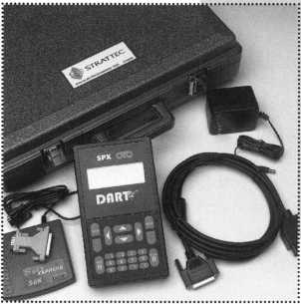

Available through STRATTEC distributors.

Applications: Domestically produced Chrysler, Dodge and Jeep.

Software requirements: Software is downloaded via a modem supplied with the locksmith version of the DART tool. Updating performed via the modem, free of charge.

Program requirements: All programming requires a four-digit, vehicle specific Personal Identification Number or PIN. PINs are available through the selling dealer's invoice or through Cross Country, the Chrysler roadside assistance carrier.

Other: Locksmiths must be on the Cross Country vendor list in order to obtain a PIN. To become a vendor, con­tact Cross Country or download the applications at [www.argosi.net](http://www.argosi.net).

Ford NGS,

approximately $1995

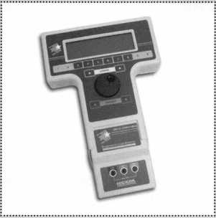

Available through Hickok Inc. distributors.

Applications: Domestically produced Ford, Lincoln, Mercury

Software requirements: Software provided on flash cards. Current version includes two diagnostic cards (RED and BLACK) and one service card (GREEN). The service card is used for performing key programming functions. Diagnostic cards used for trouble shooting and solving programming problems. Software cards updated on an annual basis. Current updates cost $895.00 and include two cards and new instructional material.

Program requirements: All key programming functions include a 10-minute delay. No PIN numbers are required. Key programming functions are located in one of seven possible modules (PATS, PCM, HEC, ICM, VIC, SCLM, SCIL). The module is year and model specific.

Other: Some cases of programming problems have been reported on 2002 and higher models where older software versions were used. Keeping all software updat­ed is recommended.

Keynotes • June 2002

2

Hellion VW/Audi HELVWTOOL, approximately $ 1150

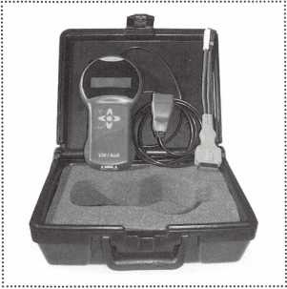

Available through Lockmasters.

Applications: VW and Audi.

Software requirements: All software is built into unit.

Program requirements: All VWs and Audis require a login code available from an authorized VW/Audi dealer. All keys must be programmed into vehicle at once.

Other: Login codes are available only through an author­ized VW/Audi dealer. Login codes up to mid-March 2002 were 4-digits in length. As of mid-March 2002, all login codes provided by dealers are 7-digits in length and require updated programming equipment to accept the new 7-digit code.

Other: If a 4-digit login code is available, it can be used to program the keys to the vehicle. The 7-digit login provid­ed by the dealer is converted to a 4-digit login by the newer or updated equipment, allowing the car to be pro­grammed. The VW Tool by Lockmasters currently only accepts the 4-digit login code, and is awaiting updates from the manufacturer. Contact Lockmasters for more infor­mation.

Nissan/lnfiniti Consult II, approximately $5000 to $6500

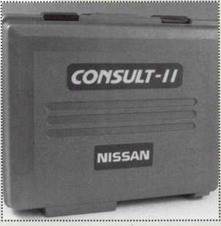

Available through Lockmasters.

Applications: Nissan and Infiniti.

Software requirements: Software provided on flash cards. Key programming functions provided on the NATS flash card. Current programming versions include 2.0 and 5.0, both are on the NATS card.

Programming requirements: Early transponder equipped Nissans use 2.0 program, late models use version 5.0. Version 5.0 requires single PIN number for all models except 2003+ Infiniti G35. Infiniti G35 uses version 5.0 and model specific PIN that is available through dealer only.

Other: Additional equipment and procedures are required for programming 2003+ Infiniti G35.

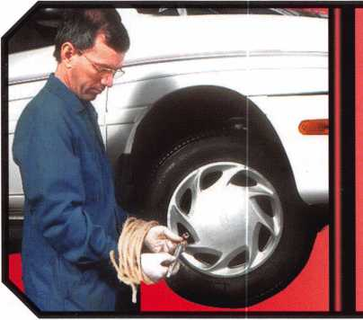

ALOA is working hard to pass

The Motor Vehicle Owner's Right to Repair Act of 2001 H.R. 2735

Increasing technology in cars is allowing car manufacturers, and not consumers, to determine where and when motor  
vehicles are serviced. By not making available vital information and tools necessary to repair today's high-tech cars to  
locksmith and other service providers, manufacturers force consumers to return to dealerships for service at a time,  
price and place of the manufacturer's representative's convenience without regard to the need of the consumer.

The Motor Vehicle Owner's Right to Repair Act of 2001 seeks to remedy this situation by ensuring the  
consumer or his agent has the right to the information necessary to repair his or her vehicle at a time and place of  
their choosing. The legislation does this without requiring car manufacturers to divulge proprietary information or

trade secrets.

Contact your representative today by going to [www.aloa.org](http://www.aloa.org)



Keynotes • June 2002

Mitsubishi MUTII,  
approximately $3150 to $3500

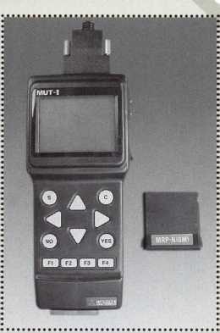

Available through Lockmasters

Applications: Mitsubishi and Mitsubishi produced Chrysler.

Software requirements: Latest version of the ROM Pack. Updated on regular basis. Contact Lockmasters for details.

Programming requirements: Programming requires 4- digit, model specific PIN number. PIN number applications included with MUTII purchase.

ASP TCL-1 Multi-manufacture, approximately $3995

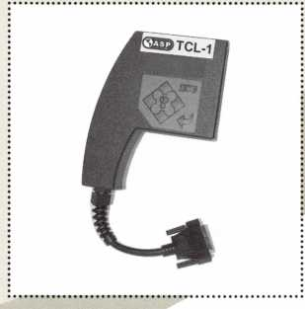

Available through ASP distributors.

Applications: Audi - all models, Volkswagen - all mod­els, Cadillac Catera - all models, Nissan - all models,

Infiniti - all models, Chrysler / Jeep - all models,

Mitsubishi - all models (including Chrysler Sebring

and other Mitsubishi- based Chrysler), Mazda - Tribute and

B-series pickup trucks (Ford based vehicles), Ford USA - All vehicles under PCM module

1 998-00 Ford Contour

1. 02 Ford Explorer
2. 02 Ford Escape
3. 02 Ford Focus
4. 02 Ford Ranger
5. 02 Ford Taurus
6. 02 Ford Windstar 2001 -02 Mazda Tribute
7. 02 Mercury Cougar

1998-00 Mercury Mystique

1. 02 Mercury Sable

Software requirements: All software is embedded. Updates made via serial cable connection after download­ing to PC.

Programming requirements: Separate adapters for proper pinning of OBDII connector.

Other: The TCL-1 was originally carried by JMA of Spain for sale in the Europe.

Ilco SDD Multi-manufacture, approximately $5000

Available through Ilco Distributors.

Applications: Finalized list not available at time of this article.

Software requirements: All software is embedded. Updates made via serial cable connection to PC and update CD.

Programming requirements: Not available at time of this article.

Other: The SDD has been successfully tested and is sold to the European market by Silca. Both Silca and Ilco have a long history in working with transponder technology and are original equipment suppliers for many car manu­facturers.

Tom Seroogy works for Lockmasters Inc. of Nicholasville, KY, is an ALOA ACE instructor teach­ing automotive locksmithing. Lockmasters Inc. is a locksmith supplier of safe, locksmith and automotive tools and equipment. For more information on transponders and the tools listed above, contact Lockmasters at (8oo) 654-0637. Q

Keynotes • June 2002

**nn mw—mfiT** wm

ie act oj manipulating tl

*««

^rras^^^a^i^^l^ttjpkalicpi Qott^^jfiilae tesgittifistftiai ydom pia tomblcr

**il«?^bWMSW^dSgMftrialtysftai ""L~:“ ' '**

**iiiatioiys in physical siz^fijotfetlie actual kick cyf**

**te4^ctw^w#w** &m[A

piat ttoa do(^stt!¥4i«d^^i%i®tr^^a^fid;t!

**>rinci]**

**while the bottom**

Is /

*pp&nm*

*L>A$mwmm& mm* stetgj

m0M th*teetic»t>kc «edtfr©sisfi

H|f» tefecb, JMfc Wigj

**J** **the sne.ar line and lock the plug.** We 3

pjtopmryed ¥nTO(wi©»>oieteiiikj

**temiftamii**

*mm*

*Am*

iip«dfeitet#t|ttte ihpM^fi«o|)gs|iqns w

iipividually wliSrt igpins in the first cl

k cylinder and that it is possible-foltnow individually wnen &&have liftei

By Sal Dulcamaro, CML

This article is the first part of what will be a multi-part article series on the subject of lock picking or manipulation. This group of articles will not deal with bypass methods in which one might attempt to get around the lock cylinder in order to manipulate the actual locking mechanism. All the different techniques and methods to be covered within this article series will deal with the act of manipulating the tumblers within the lock cylinder, to accomplish what is normally done by the key. The primary emphasis of the series will be on pin tumbler locks, but may expand a bit beyond that.



Keynotes • June 2002



This first part will not cover any specific picking techniques or methods. Instead, it will lay the groundwork by providing a detailed explanation of the internal mechanics of a pin tumbler lock cylinder and what conditions are required for such a lock cylinder to be in an “unlocked” state. In upcoming issues of Keynotes, other articles will detail a variety of specific picking techniques.

Inside a Pin Tumbler Lock Cylinder

Figure i is a side cutaway view of the internal layout  
of a typical pin tumbler lock cylinder. It has five  
filled pin chambers, which is probably the most  
common tumbler configuration that you will see.

You may sometimes find these types of locks with as

or seven chambers filled, or as few as four.

many as six

There are some locks with other pin chamber configura-  
tions, but they are rare. There will be variations in physical size  
of both the actual lock cylinder and the tumblers within it. The  
principles of lock operation are basically the same, but the effectiveness of  
picking techniques will vary as well as the types (and sizes) of tools needed for picking.

Pin chambers are drilled to a particular depth into the plug and don’t usually drop all the way to the bottom of the plug. There is space below the tumblers for lock picking tools to be inserted and manipulated. Unless master keyed, most typical pin tumbler locks will con­tain two pin tumblers within each chamber. The top pin (or driver) is usually flat on both sides, while the bottom pin is usually flat on top (where it contacts the top pin) and almost pointed on the bottom (where it contacts the key). A tumbler spring is usually found on top of the pin stack, just above the top pin.

The pin chambers within the plug are considered the lower chambers, while the chambers within the lock cylinder shell are called the upper chambers. If there were no tumblers in the lock cylinder, the plug would be able to freely rotate or spin within the lock cylinder shell. The plug is locked in place and unable to rotate when at least one tumbler partially extends from plug into the shell. When tumblers are in the lock, the only way to free up

Keynotes • June 2002

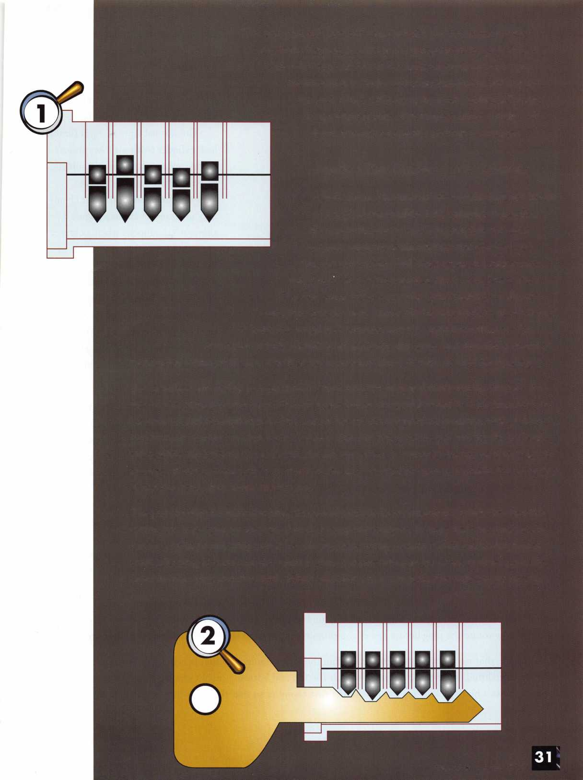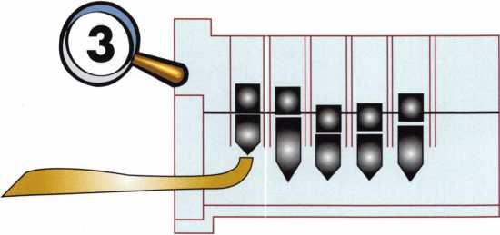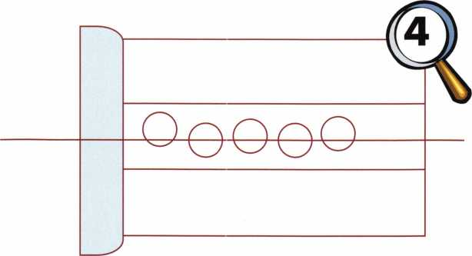

line where the top surface of the plug contacts the inside of the (allowing the plug to rotate) is called the shear line.

and allow the rotational movement  
of the plug is by having all the tum-  
blers either fully in the plug or the  
shell. If any tumblers straddle  
between the upper and lower pin  
chambers, the plug cannot turn.

The normal state of a pin tumbler  
lock cylinder (without a key inserted)  
is what we see in figure i. Tumblers  
(specifically top pins) straddle  
between the upper and lower cham-  
bers in all five chambers. Figure 2  
shows what happens when a correct  
operating key is fully inserted into  
the keyway of the lock. The depths  
of the key cuts raise the individual  
pin stacks so that all the top pins stay  
within the upper chambers and all  
the bottom pins remain within the  
lower chambers. They split along a  
shell. The surface where separation occurs

The basic rule of locking is that if any tumbler crosses through the shear line and extends into both the upper and lower chambers, the plug will not turn and the lock would be considered to be locked. It doesn’t matter how many of the remaining pin chambers have no obstructions along the shear line. It only takes one pin to cross the shear line and lock the plug. We know how a correct key unlocks the plug. It raises all the pin stacks to split at the shear line all at the same time. To pick or manipulate a lock cylinder we need to create the same basic unlocking condition without access to the key.

Manipulating the Tumblers

When generally portrayed in movies or on television, lock picking just looks like someone inserting a pick into the keyway of a lock and jiggling it for a few seconds until the lock magically opens. This method is fairly effective when dealing with locks that are already unlocked, but takes a bit more effort and skill to accomplish when the door lock is really locked. Regardless of technique, there is an absolute minimum required for suc­cessful lock picking. You must manipulate all the tumblers into positions where they don’t cross the shear line, and somehow rotate the plug before any of the tumblers move back far enough to block the shear line again.

Let’s imagine that we know all the pin sizes within the lock cylinder and that it is possible to know individually when we have lifted any specific pin stack so that the top and bottom pins slit exactly along the shear line. Figure 3 shows a hook pick lifting the pins in the first chamber so that the shear line (in the first chamber) is

Keynotes • June 2002

not blocked. It looks like we are on our way to picking open this  
lock. We know what the second pin is and we know how far to  
lift it so that that chamber will also split at the shear line.

Stop for a minute. If you don’t know how lock picking works,  
you may think we just let go of the first pin that we raised to  
the shear line and proceed to the next chamber. We have a  
slight problem. That pin chamber won’t remain picked on its  
own. In fact, the moment we let go of the first pin, the pin  
stack will drop and the shear line in that chamber position will  
be blocked again. It is possible to raise the second pin stack to split

at the shear line, but (like the first chamber) the stack will only remain  
split at the shear line as long as we hold it there. When picking one turn

bier at a time, we will always have to deal with four more pin stacks  
that will not remain picked unless some method is devised to keep  
the shear line unobstructed in those chamber positions.

Manufacturing Imperfections and  
Binding Tumblers

When picking a lock, we don’t have the luxury of how the cor-  
rect operating key keeps the shear line unobstructed. The key  
has something positioned under each pin stack to keep it from  
dropping and to hold each stack split at the shear line. Figure 4 is

slightly exaggerated, but illustrates the fact that the pin chamber holes  
are never perfectly centered in a row along the centerline. Depending on the

precision of the manufacturing equipment and processes, the variation off center can be quite small or much greater. Pin diameter, lock wear and other things also have an effect, but these imperfections are the key to keeping tumblers picked while proceeding to the others.

Figure 5 shows a front cutaway view of a single pin chamber. When undisturbed, the pin stack rests at the bot­tom of the pin chamber and roughly centered within that chamber. In this condition, the pin stack should easi­ly and smoothly move up or down within the pin chamber.

When clockwise plug rotation is attempted in figure 6, the plug will rotate ever so slightly before the top pin binds between the left inside surface of the bottom chamber and the right inside surface of the top chamber. Since the pin chambers are not perfectly centered along the centerline running from the front to the back of the lock cylinder, usually only one chamber at a time will have bound pins. This is an important factor when picking one chamber at a time. It will help us keep picked pin chambers in the picked condition as we go from chamber to chamber until all chambers are picked and the plug ultimately rotates to unlock the lock.

I will leave you in suspense here until part two (next month), when we will apply that information when we learn how to pick one pin at a time. If you wish to contact me, you can go to my web site at [http://home.earth- link.net/-lockwriter](http://home.earth-link.net/-lockwriter) . Look for the link to “Tech Article Addendum” and click on it. Updates and corrections are posted there, plus there is an e-mail link if you wish to contact me. Q

Keynotes • June 2002

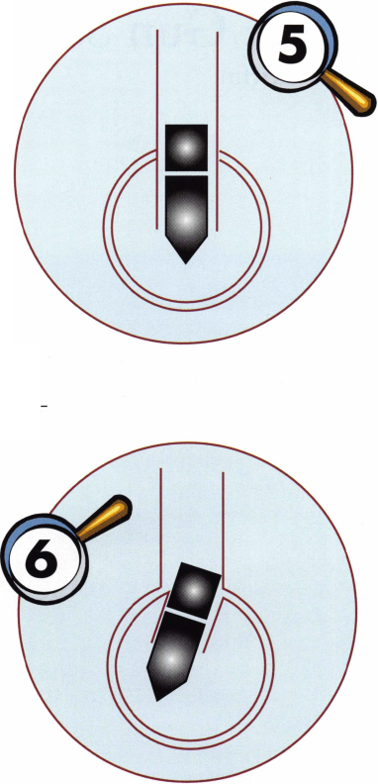

SAFES: Gun Safe Disarmed

By Mike Griffin

The combination lock on this safe worked properly, and the lock bolt would retract... but the safe would not open. WE could hear the distinct sound of metal hitting when the handle was turned, indicating a fired exter­nal relocker. We dialed the combination and retracted the lock bolt, then carefully pulled the dial, making sure that the lock bolt stayed retracted. Next, we drilled a 1/4-inch hole next to the lock box, but still under the dial ring. Then we inserted a stiff pegboard stopper into the hole and pushed the trigger plate completely out of the way so as not to interfere with retracting the external relocker. Our next step was to insert picture hanging wire (available at most hardware or knick-knack stores), looped it and pushed it into the 1/4” hole. (Photo 1 shows the safe with the picture-hanging wire looped out of the hole; photo 2 shows the loop itself.) Next, we inserted a 90-degree scope. We fished with the wire by holding one end and pushing the other, making a large loop to hook the roll pin in the relocker. Once hooked, we pulled back on the wire and it tightened on the roll



Keynotes • June 2002

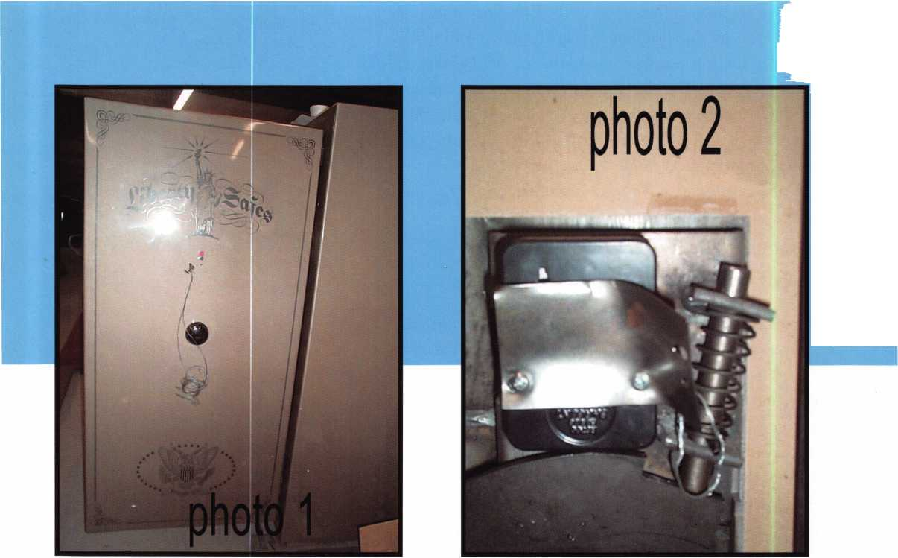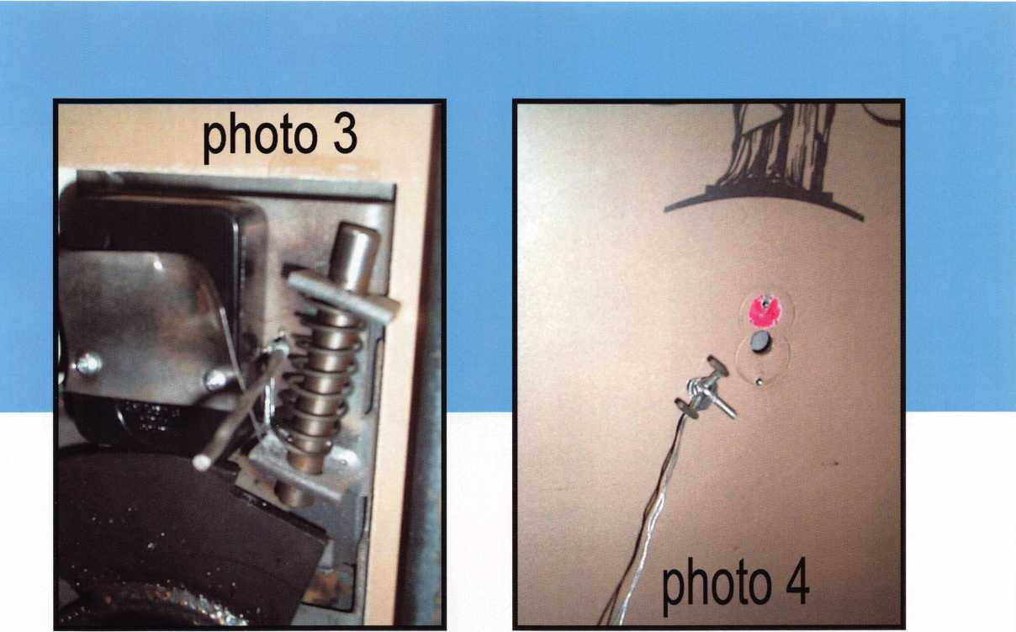

pin. At this point, we inserted the pegboard stopper back in the hole (photo 3), wrapped the end of our wire around the stopper and turned it, which wrapped the cable around the stopper, pulling the relocker straight up. We rolled the cable around the peg instead of pulling on the cable, so that the cable didn’t get cut on the rough edge of our hole. (Photo 4 shows the outside of the safe with the peg in the hole and the wire wrapped around it.)

Using this method to open gun safes under the dial makes the repair possible under the dial ring. Due to the lifetime warranty offered by many gun safe manufacturers, any hole outside the dial ring will cause the cus­tomer to demand a replacement safe. Using this method will not only prevent having to replace the safe, but it will also make a manufacturer paying for a warranty claim in your area many times more likely to call you for their next warranty claim. And that’s just fine with us. Q

Keynotes • June 2002



**ALOA 2002  
Exhibitors**

**Current listing as of  
5/3/2002**

1 -800-Locksmith 1324

A & B Safe Corporation 400 A-l Security Manufacturing

Corporation 308

Aable Locksmiths 1411

Abloy Door Security 805

Abus Lock Company 410/412 Access Hardware Supply 1233 Ace Lock & Security Supply 507 Adams Rite Mfg. Company 721 Adesco Safes 824

ADI, Inc 1121

Adrian Steel Company 302 Advanced Security Products 1529 ALOA 1420

Alarm Lock Systems 503

Alden Corporation 711

Allied Locksmiths of Illinois 313 Allstate Insurance Company 713 American Eagle Lock

Company 301

American Lock Company 1309 American Security Products 520 Architectural Control

Systems 1227

Armadillo Firearm

Security Products 1601

Arrow Lock 809

ASP, Inc 1515

ASSA Abloy 905

ASSA Inc 804

Blackhawk Products 1125

Buddy Products 1610

Burg-Wachter

North American 1711

BWD Automotive 710

Camden Door Controls 501 CCL Security Products 725

Clark Security Products 1504 Clearstar Security Network 311 Commercial Van Interiors 303 Compx Security Products 1120 Corporate Safe

Specialists, Inc 1 313

Crow Electronic

Engineering, Inc. 526

Defiant Safe Company 11 29

Desktop Dispatcher 1409

DETEX Corporation 515

Dia Safe Inc 1408/1410

FRAM0N

MFG.

320

LOCKEY

CORP.

421

LOCKSMITH

ASSOC.

315

ALLIED

LOCKSMITH

313

FOX

VALLEY

317

CLEAR

STAR

31 1

GCLA

309

307

CpMMERCIA  
VAN

303

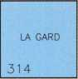

|  |  |
| --- | --- |
| SECURITY | 41 1 |
| 308 | 409 |

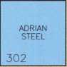

|  |  |  |
| --- | --- | --- |
| 432 | ■ | 533 |
| 430 | 531 |
| 428 |  | 529 |
| FH | ■  ~E | 527 |
| 424 | VIDEX  521 |
| 422 |
| VAN  LOCK  420 | ■ |
|  | | |
| SELECT  =R0DUCTE  416 |  | DETEX  515 |
| 414 | ■ |
| ABUS  LOCK  410 | 51 1 |
| l-H |  | WILSON  SAFE  509 |
| HERCULES  PADLOCK  406 | ACE  LOCK  507 |
| PRO  BUSINESS  404 | ALARM  LOCK  SYSTEMS  503 |
| VOS  SYSTEMS  402 | ■ |

|  |  |
| --- | --- |
| 532 | 633 |
| 530 | 631 |
| 528 | KUSTOM  KEY  627 |
| CROW  ELECTRONIC  526 |

AMERICAN

SECURITY

PROD.

520

|  |  |  |
| --- | --- | --- |
| ■  PRO-STEEL  SECURITY  PRODUCTS  630 | | |
| 628 |  | 729 |
|  | ■ | /ANDERSTEEf |
| 626 |  | 727 |
| PHOENIX |  | CCL |
| SAFE |  | SECURITY  725 |
| 622 |  | ADAMS |
| ZIPF  LOCK |  | RITE |
| 620 |  | 721 |

|  |  |
| --- | --- |
|  | OMAHA  WHOLESALE  833 |
|  | 831 |
| SECURITY  3ES0URCEL | SECURITY  DIST. |
| 726 | 827 |

DYNALOCK

832

828

ADESCO

SAFE

824

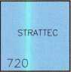

VASTER

LOCK

820

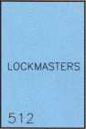

RUTHERFORD

CONTROLS

616

jOUTHWEST

SPEC.

|  |  |
| --- | --- |
| GARDELL  SAFE | JET  HARDWARE |
| 506 | 607 |
| 504 | LOCKSMITH  LEDGER  INT'L.  603 |
| JACKSON  CORP.  502 |

612

610

MIDWEST

WHOLESALE

606

MAG

SECURITY

602

TURN 10 WHOLESALE

715

ALLSTATE

INSUR.

713

ALDEN

71 1

KSP

709

SARGENT

&

GREENLEAF

703



|  |  |
| --- | --- |
| BWD |  |
| 710 | ARROW |
|  | LOCK |
|  | 809 |
| u.s.  LOCK | ABLOY  DOOR |
| 704 | 805 |

MUL-T

LOCK

812

ASSA

804

|  |  |  |  |
| --- | --- | --- | --- |
| 301 | 300 | 401 | 400 |
| AMERICAN |  |  | A & B |
| EAGLE |  |  | SAFE |

|  |  |
| --- | --- |
| 501 | 500 |
| CAMDEN | PDQ |
| DOOR | MANUF. |
| CONTROLS |

600

INNOVATIVE

MOVING

**SYSTEMS**

Show Office

|  |  |  |  |
| --- | --- | --- | --- |
| Digital Systems Inc | ...1615 | Gardall Safe Corporation | 506 |
| Direct Security Supply, Inc | ...1328 | Greater Chicago Locksmiths |  |
| Don-Jo Manufacturing Inc | 1127 | Association | 309 |
| Doorking | 1423 | Hayman Safe Co | 1029 |
| Dorma Architectural |  | HES, Inc | 1012 |
| Hardware | 1130 | Hercules Padlocks | 406 |
| Dugmore and Duncan, Inc. | 1126 | High Tech Tools | 928 |
| Dynalock Corporation | 832 | Homeowners Marketing |  |
| EZ Change Lock |  | Services | 1616 |
| Company 1509/1511 | | Howard Keys | 1224 |
| Eclipse Industries | 1701 | HPC, Inc | 714 |
| Emergency Road Service | .1322 | IDN Corporation | 1214 |
| Emtek | ...1016 | Innovative Moving |  |
| ESP Lock Products Inc  Ewert Wholesale | 1405 | Systems, Inc.  Institutional Locksmiths | 600 |
| Hardware, Inc | 1512 | Association | 315 |
| Fox Valley & Indianhead |  | Intralock Tools Ltd | 1716 |
| Chapter of ALOA | 317 | IR Security & |  |
| Framon Mfg. Company, Inc. | 320 | Safety 920;921 | ; 1020 |
| Frontier Safe Company | 1406 | Jackson Corporation | 502 |

Jet Hardware Manufacturing Company 607

Joseph A. Thomas Ltd

dba Bad Dog Tools 1401 KABA ILCO/KABA AMS 1102 Keedex Manufacturing 1510

Keri Systems, Inc 1723-1725

Key Systems 1325

Knaack Mfg/

WeatherGuard 1700-1801 KSP 709

Kustom Key 627

LA Safe & Vault 612/614

LAB Security 1210

La Gard Inc. 314

Lockey Corp 421/423

Lockmasters, Inc. 512

Locksmith Ledger

International 603

Locktools Company 1 231

Keynotes • June 2002

Plan on attending the 2002 ALOA Security Expo. Show Dates/Hours are: FridayJuly 26, 12 Noon-5 pm  
Saturday, July 27, 12 Noon-5 pm • Sunday, July 28, 12 Noon -4 pm

|  |  |
| --- | --- |
|  | OLMPUS  LOCK  1033 |
| IIGH  ECH | HAYMAN  SAFE |
| 281 | 1029 |

IR

SECURITY

20

PHI

1032

1020

DIF1ANT

SAFE

1129

DON-JC

1127

BLACKHAWI

1125

ADI

1 121

|  |  |
| --- | --- |
| 1  DORMA | ■access  HARDWARE  1233 |
| ARCH.  1130 | LOCKTOOLS  1231 |
|  | SUN  SAFES |
| DUGMORE AND i | 1229 |
| DUNCAN * | *ARCH.  CONTOL |
| 1 126 | 1227 |

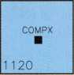

|  |  |  |
| --- | --- | --- |
|  | | 1333 |
| vlARKAR  PROD.  1228 |  | 1331 |
| SENIOR  TECH.  1329 |
|  |  |  |

|  |  |  |
| --- | --- | --- |
| HOWARD  KEYS  1224 |  | KEY  SYSTEMS  1325 |
| LUCKY |  | MUTUAL  SAFE  1323 |
| LINE |  |  |
| 1220 |  | 5ECURITECI  1321 |

|  |  |
| --- | --- |
| 1332 | 1433 |
| 1330 | 1431 |
| DIRECT  SECURITY  SUPPLY  1328 | SECURA  KEY  1429 |

|  |  |
| --- | --- |
| 1-800  LOCKSMITH  1324 | southern  LOCK  1425 |
| [MERGENCE  ROAD  SERVICE  1322 | DOORKING  1423 |
| ROFU  1320 | MARKS  1421 |

|  |  |  |
| --- | --- | --- |
| 1432 | ■  ■ | ■—  1533 |
| 1430 | 1531 |
| MBA-USA  1428 | ADVANCED  SECURITY  1529 |

|  |  |
| --- | --- |
| 1532 | 1633 |
| 1530 | 1631 |
| SAVTA  1528 | PLS  1629 |

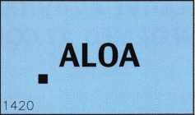

|  |  |  |
| --- | --- | --- |
| 1632 |  | 1733 |
| SECURITY  DOOR  1628 | 1731 |
| 1729 |
|  | ■ |  |
| SUPRA  PROD.  1624 | KERI  SYSTEMS  1723 |
| S.E R.L.A.C  1622 |
| SPEEDYPlK  1620 | ■ | MAJOR  MANUF.  1721 |

|  |  |
| --- | --- |
| 1732 | 1833 |
| 1730 | 1831 |
| 1728 | 1829 |

|  |  |
| --- | --- |
| 1724 | 1825 |
| 1722 | 1823 |
| VISONIC  1720 | RODMAN &  CO.  1821 |

SECUR1T0N

MGNALOCK

14

YALE

SECURITY

04

EMTEK

1016

HES

1012

SARGENT

MANUF,

1113

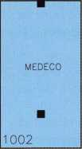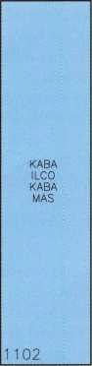

ENTRANCE

IDN

CORP.

1214

LAB

SECURiT'

STRONG

ARM

SECURITY

1317

CORP.

SAFE

SPEC.

1313

. ^ - AMERICAN

LL£_Lii«BL0«

|1 309

SECURITY

LOCK

D1ST.

1202

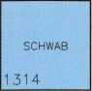

|  |  |
| --- | --- |
| MDS  INC.  1310 | AABLE  LOCKSMITH  141 1 |
| MEILINK  FIRE  KING  1306 | DESKTOP  DISPATCH  1409 |
| ESP  LOCK  1405 |
|  |



’ift1

DOG

TOOLS

1414

ASP

1515

DIA

SAFE

1408

FRONTIER

SAFE

1406

RA-LOCK

1404

EZ

CHANGE

LOCK

1509

1505

|  |  |
| --- | --- |
| "SI OKIE”  BERG  1516 | S.  PARKER  1617 |
| 1514 | DIGITAL  SYS.  1615 |
| EWERT  WHOLESALE  1512 | 1613 |
| KEEDEX  MANUF.  1510 | OSI  SECURITY  161 1 |

iOMEOWNERS

**marketing**

SERVICES

1616

LOCKSMITH

STORE

1614

1612

BUDDY

PROD.

1610

VINGCARD EL SAFE

1717

1715

BURG

WACHTEF

171 1

|  |  |  |  |  |  |  |
| --- | --- | --- | --- | --- | --- | --- |
| 1400 |  | 1500 | 1602 | 1601 | 1600 | 1701 |
| ULTRA  LIFT |  |  |  | ARMADILLO  FIREARM |  | FCL1PSE |

|  |  |
| --- | --- |
| INTRALOCK  TOOLS  1716 | 1817 |
| PFAFFENHAIN  -N.A.  1714 | 1815 |
| 1712 | 1813 |
| 1710 | 181 1 |

|  |  |  |  |  |
| --- | --- | --- | --- | --- |
| CLARK  SECURITY |  | W- LOK |  | NATIONAL  LOCKSMITH |
| 1504 |  | 1 604 _ |  | 1704 |

1700

KNAACK

MANUF.

|  |  |  |  |  |  |  |  |
| --- | --- | --- | --- | --- | --- | --- | --- |
| Lucky Line Products, Inc | 1220 | PHI Enterprises, Inc | 1032 | Secura Key | 1429 | Strong Arm Security, Inc | 1317 |
| MAG Security | 602 | PLS Group | 1629 | SecureRite.com | 1505 | Sun Safes Manufacturing | 1229 |
| MMF Industries | 933 | Pfaffenhain-North America | 1714 | Securitech Group, Inc | 1321 | Supra Products, Inc | 1624 |
| Major Manufacturing, Inc. | 1721 | Phoenix Safe 622/624 | | Securitron Magnalock |  | The Locksmith Store | 1614 |
| Markar Products Inc | 1228 | PRO-LOK | 1414 | Corporation | 914 | The National Locksmith | 1704 |
| MARKS, U.S.A. | 1421 | Pro-Steel Semritv Products | 630 | Security Distributors Inc. | 827 | Turn 10 Wholesale | 715 |
| Master Lock Company | 820 | Professional Business Products 404 | | Security Door Controls | 1628 | U.S. Lock Corporation | 704 |
| MBA-USA, Inc | 1428 | RA-Lock Company | 1404 | Security Lock Distributors | 1202 | Vandersteen & Sons | 727 |
| MDS Incorporated | 1310 | Rodman & Company | 1821 | Security Resources Inc | 726 | Ultra Lift | 1400 |
| Medeco | 1002 | ROFU International Corp | 1320 | Select Products Limited | 416 | Van Lock Company | 420 |
| Meilink/Fire King | 1306 | Rutherford Controls Inc -RCI | 616 | Senior Technologies, Inc | 1329 | Videx | 521 |
| Midwest Wholesale |  | S. Parker Hardware |  | S.E.R.L.A.C | 1622 | VingCard El Safe | 1717 |
| Hardware 606/608 | | Manufacturing | 1617 | Southern Lock and |  | Vi sonic Inc | 1720 |
| Mul-T-Lock USA, Inc | 812 | Sargent & Green leaf, Inc | 703 | Supply Company | 1425 | Vos Systems | 402 |
| Mutual Safe Company | 1323 | SARGENT Manufacturing |  | Southwest Specialty Products | 610 | W-Lok Corp | 1604 |
| Olympus Lock Company | 1033 | Company | 1113 | Speedypik | 1620 | Wilson Safe Company | 509 |
| Omaha Wholesale |  | SAVTA | 1528 | Stone & Berg Wholesale | 1516 | Yale Security Group, Inc | 904 |
| Hardware | 833 | ScanLock | 828 | STRATTEC Security |  | Zipf Lock Co | 620 |
| OSI Security Devices | 1611 | Schwab Corporation | 1314 | Corporation | 720 |  |  |
| PDQ Manufacturing | 500 |  |  |  |  |  |  |

Keynotes • June 2002

**3**



NUMEROUS LEGISLATIVE ACTIVITIES WILL KEEP YOU INFORMED AT CON­VENTION!!!

Find out what's the latest happening in your state capitol. Contact your state representative or senator about a certain bill. Let your Governor know exactly what you think about him/her. Get free popcorn. Come to the "Thank You!" reception if you're a Legislative Action Network member. This is just some of what you can expect this year from the Government Affairs department at the ALOA 2002 Convention and Security Expo in Rosemont, Illinois. Here are some of the highlights:

Friday July 26, 2002 thru Sunday July 28, 2002 Noon to 5pm (Noon to 4pm Sunday)

GOVERNMENT AFFAIRS BOOTH AT SECURITY EXPO

Once again, we'll have the popcorn machine serving up fresh hot buttered popcorn but now we've added activities that you can participate in as well! On site we'll have information on all bills, and legislation in your state PLUS our NEW "Locksmith Lobbying for Licensing: A Guide for Influencing your State Legislature and Governor." Free Convention mer­chandise for Legislative Action Network Council ($+100 and up) mem­bers.

Saturday, July 27, 2001 12:30pm to 1:30pm

LEGISLATIVE ACTION NETWORK "THANK YOU!" LUNCHEON

As a way to say "THANK YOU" for all your hard work, ALOA is giving a luncheon for all members of the Legislative Action Network (LAN) and Council at the Hyatt Regency O'Hare. This by-invitation-only event will be the perfect way to celebrate the MANY legislative victories the association has had this year.

Saturday, July 27, 2001 2pm to 3:30pm

STATE OF THE STATES ROUNDTABLE

This meeting is designed as a forum for ALOA chapters and local/state regional locksmith associations to share information about the state of lock- smithing in their region and a dynamic way to share ideas. Primarily for the Chairman, President and Legislative representative from each organiza­tion, all locksmiths are encouraged to participate. This is the perfect opportunity to learn about what's going on in the industry across the nation.

LEGISLATIVE SUMMARY

ALOA worked very hard this year on legislation affecting the security industry. We actively worked on 16 bills in 14 states that had a direct impact on our members and all locksmiths.

There were two alarm bills introduced this year. The bill in Mississippi never made it out of committee, and the bill in Ohio is in a sub-committee. In Illinois the Private Detective, Private Alarm, Private Security and Locksmith Act of 1993 is going through some changes in anticipation of the sunset provisions that will take effect in 2003. In Minnesota they intro­duced a bill that requires criminal background checks for "electronic secu­rity system companies" which is further defined as "burglary detection, access control, or closed circuit television." However, this is in the criminal code, not the licensing code (where electronic security system is not defined), so we will have to see how this is interpreted. Pennsylvania introduced a bill that establishes the Electrical Contractors Licensing Board. The definition of alarm system reads, "Any electrical device, signaling device or combination of electrical devices used to signal or detect a bur­glary, fire, robbery or medical emergency." NBFAA joins ALOA in oppos­ing this bill because it puts alarm licensing under someone else's board (Electrical Contractors).

In Connecticut, the state attempted to amend existing laws to bring in access control and CCTV, but ALOA was successful in defeating the bill.

In Maryland, the State Police attempted to define a "security system" as only including locking devices. We saw this as an opportunity to get lock­smiths registered in Maryland and proposed an amendment that redefined the bill to our liking. However, it died in committee because legislators felt the process was rushed.

The Ohio Burglar and Fire Alarm Association introduced their alarm licens­ing bill, which creates the "Commission on Electronic Security System Regulation" in the Department of Commerce. The definition of electronic security system reads, "an assembly of electronic equipment and devices, which may include access control and closed circuit television, that for its main purpose detects threats, intrusions, or security violations that jeopard­ize the safety of life or property." ALOA offered an amendment to exempt locksmiths so long as the system they install is not connected to an electron­ic security system used to signal the presence of an emergency to which law enforcement or emergency services are expected to respond. Staff for the bill's sponsor did not accept our offer. Consequently, the Ohio Locksmith Association hired a lobbyist, who is already making an impact.

Attempts to get locksmith licensing bills introduced in Connecticut and passed in Kansas and South Carolina were unsuccessful.

CHECK OUT ALOA'S WEBSITE AT <http://www.aloa.org/news/legcom.cfm>

FOR THE LATEST HAPPENINGS IN YOUR STATE



Keynotes • June 2002

2002 LEGISLATIVE HIGHLIGHTS CALIFORNIA AB143

Requires locksmiths to be a licensed contractor or to maintain a $250,000 liability insurance policy. Died in Committee.

CONNECTICUT HB5615

Requires the licensing of security systems and fire alarm sellers, installers and monitors. Nowhere does it define "security system." Died in Committee.

FLORIDA SB964

Requires membership of the Electrical Contractors' Licensing Board to include local certified alarm contractors. Withdrawal from further consider­ation pending.

GEORGIA HB1082

Minor word change, no impact on low-voltage contractors. To House Committee on Industry.

KANSAS HB2887

Provides for regulation and licensure of locksmiths. Died in Committee.

ILLINOIS HB3663

Provides that a person who applies for licensure as a locksmith agency between September 1, 2002 and December 31, 2002 shall be exempt from the examination requirement. To House Committee on Rules.

ILLINOIS SB 1558

New PERC Card provisions. Passed House and Senate.

MARYLAND SB 125

Continues the licensing and regulation of security systems technicians until 2016. Signed by Governor.

MARYLAND HB1004

Clarifies the State Security Systems Technicians on Economic Matters: Died in Committee.

MINNESOTA HB2787

Requires that employees of electronic security system companies undergo criminal history background checks. Passed House.

MISSISSIPPI SB2482

Relates to the licensing and regulations of installing burglar alarms.

Died in committee.

NEW YORK SB 1859

Provides a possible tax credit in cities of one million or more for security improvement measures. From Senate Committee on Cities.

OHIO HB452

Alarm licensing bill. Sent to sub-committee in the Committee on Commerce and Labor.

PENNSYLVANIA HB2075

Regulates the licensure of electrical and alarm system contractors.

To House Committee on Professional Licensure.

SOUTH CAROLINA SB381

Provides for regulation and licensure of locksmiths. Died in Committee.

TENNESSEE SB2087

Renews the Alarm Systems Contractors Act until 2006. Passed Senate to House

LOUISIANA LOCKSMITH LICENSING

In 2001, the Louisiana legislature passed sweeping legislation that repealed a number of licensing laws that were on the books, but never enforced. The Locksmith Licensing Act of 1997 was one of those laws repealed.

JOIN THE LEGISLATIVE ACTION NETWORK TODAY!

As we continue to expand our resources and become more competitive in the legislative arena, we need the monetary resources to match our suc­cesses You can help with as little as $24.95 to the Legislative Fund This is only the minimum that we are asking, and encourage you to give more if you can Those that contribute will be given a Legislative Action Network Member kit to use in their grass roots efforts Members who donate $100 or more become Legislative Action Network Council members, and enjoy the following extra benefits: Discounts on ALOA bookstore items; 10 % rebate on all ACE classes; Complimentary Legislative Convention merchan­dise Join today by going online at: <http://www.aloa.org/news/lan.htm>.

Copies of all these bills can be found at  
[www.aloa.org/news/legislation.cfm](http://www.aloa.org/news/legislation.cfm)

3

Keynotes • June 2002

**3**

EMPLOYMENT

WANTED: LOCKSMITH / MOBILE SERVICE TECHNICIAN

Join Kentucky's largest security team! Full-time position, excellent benefit package, wages commiserate with experience & abilities. CONTACT: Bryan Turner 800/928-5625 or 502/893-0441, [BTURNER@WILLISKLEIN.COM](mailto:BTURNER@WILLISKLEIN.COM) • Willis Klein Safe, Lock & Decorative Hardware • 4041 Westport Rd. Louisville, KY 40207

SUPERVISOR, LOCK SHOP

LOCATION: KWAJALEIN ATOLL IN THE MARSHALL

ISLANDS

Raytheon Range Systems Engineering is the leader in the field of Range Engineering, maintenance and base support of military and government radar facilities. Raytheon's involvement is in support of the United States Army at the Kwajalein Atoll. Under the direction of the FOM Manager, directs the Lock Shop Staff in their daily duties. Services and installs all types of locks and Security Life Safety hardware on wood and metal doors, desks, filing cabinets, panels, containers and special applications. Performs preventive maintenance on locks at all USAKA facili­ties. Services and repairs Safes and GSA Containers.

* Must understand and promote good safety practices at all times.
* Shall ensure that all Government Property assigned is secured and properly cared for during use in accordance with RSE Standard Practice Instructions pertaining to property manage­ment.
* Coordinates and supervises the daily operation of the Lock Shop.
* Explains and demonstrates proper work methods, procedures and goals to the Lock Shop Staff.
* Orders and coordinates delivery of materials and equipment for the completion of assigned tasks. Monitors usage of mate­rials to ensure usage is consistent with scheduled work activi­ties.
* Works with the Raytheon Security Dept., Engineering Dept., Corp of Engineers, PMO and other organizations to ensure that Lock and Hardware installations meet Security, Fire, Life Safety, ADA and NEC requirements.
* Inspects new or renovated facilities and ensures contractor material and system compliance.
* Services and installs all types of Locksets and Builders Hardware.
* Build manually or by computer, Master Key System.
* Service & Repair Safes and GSA Containers.
* Works with the Locksmith in the continuing training of the Locksmith Assistant.
* Electronic Access Control and Alarm Installation & repair of the Locksmith Assistant.
* Perform related duties as assigned or as the situation dictates.

Requirements:

* Must be able to obtain a Security Clearance.
* Must have extensive knowledge of Locksmithing and Security/Life Safety Hardware.
* Must be able to read and interpret blue prints, engineering drawings and wiring diagrams.
* Must have extensive knowledge of the proper use of hand tools, power tools and shop equipment and machines.
* Must have extensive knowledge of building construction & materials.
* Must have GSA Certification with 5 years experience.

Additional Information

Position Type: Full Time, Employee

Contact Information: Maddy Goff Model ine_Torres-

[Goff@raytheon.com](mailto:Goff@raytheon.com)

Raytheon Technical Services AL • Fax: 256-971-2579

Classified Advertising Policy

Classified advertising space is provided free of charge to ALOA members, and fora fee of $.60 per word, $15 minimum for non-members. Classified ads may be used to advertise  
used merchandise and overstocked items for sale, "wanted to buy" items, business opportunities, employment opportunities/positions wanted and the like. Members or non-members wishing  
to advertise services or new merchandise for sale may purchase a "Commercial Classified Ad," for a fee of $1.30 per word, with a minimum of $40. Each ad will run for two issues. For blind  
boxes there is a $5 charge to members and non-members. All ads must be submitted in writing to the ALOA office by the fifteenth of the month, two months prior to issue date. Send to  
Keynotes Classifieds, 3003 Live Oak St., Dallas TX 75204-6186. ALOA reserves the right to refuse any classified advertisement that it deems inappropriate according to the stated purpose

of the classified advertising section.

Keynotes • June 2002



KWIK KEY OF SOUTH FLORIDA

is looking for experienced commercial locksmiths. Work in Sunny Florida. Salary starts @ $620 per week. Call 305/770-2490, and ask for Mr.

Fred Zimmerman.

EXPERIENCED LOCKSMITH WANTED

Las Vegas-based company that deals with all phases of surveillance, access control and locksmithing is looking for a highly qualified and motivated individual to perform locksmith duties. Vegas Valley Locking Systems, Inc., has an established customer base and is expanding. Qualified individuals will have extensive experience in locksmithing safes and door hardware. Electronic hardware experience is a plus. Great bene­fits. Salary DOE.

Please contact us and/or fax resume to: James Rochester 6207 Industrial Road • Las Vegas, NV 89118 702/614-3939 (phone) • 702/614-8052 (fax)

EXPERIENCED LOCKSMITHS

Growing, established 23-year company is seeking lead locksmiths. Experienced required in commercial locksmithing, including safe work and electronic access/CCTV, panic hardware, master key systems. Work in and around the nation's Capitol. Excellent opportunity for individual dedi­cated to the trade and customer service. Company-provided vehicle, tools, uniforms. Salary commensurate with experience. Inside position also avail­able. Paid holidays, vacations, health insurance, 401 (k). Please fax resume to 301/424-3080, or call 888/424-LOCK (5625), ext. 14.

**TURPI ID**

WHOLESALE SERVICE

* In-Stock... **SAFES**
* FREE Freight Program
* Fax: 800-391-4553

800**-**848-9790

AMSEC FreKing **Gaffill** HAYMAN MEILINK \4c7D/?

BUSINESS FOR SALE

NEED A CHANGE IN THE WEATHER?

A well-established lock and safe business is for sale in sunny Orlando, FL! Owner is retiring (after a smooth takeover transition). 20 years at present location with a long-term lease, two fully-stocked service vans, inventory and equipment worth well over $120K with a long list of commercial and residential accounts grossing over $200K. Asking $190K. Serious inquiries call 407/277-51 77, ask for John.

WORK WANTED

NORTHERN NEW JERSEY/NEW YORK CITY AREA

Institutional Locksmith looking for a position with a quality company. Familiar with Medeco as well as other cylindars and door hardware.

Do not wish to relocate. Call James at 973/742/4979 or 973/819-1047

SECURITY PRO FOR HIRE

CML, CPS seeks a challenging and personally rewarding position as a Locksmith at the supervisor or management level. Would prefer institution or college in the Midwest or central United States, however all locations would be considered. 30+ years in the field and well versed in all aspects of sales, training and management. Please respond to the editor of ALOA, (800)532-2562, ext. 19.

WANTED TO BUY/SELL

FOR SALE:

Locksmith tools, code books, hardware, key blanks. Framon, Curtis, Aero, Schlage, LSDA. For complete list, contact Gary at P.O. Box 52, Conover, Wl, 54519, phone 330/418-1689 or e-mail: [gary@cybertekweb.com](mailto:gary@cybertekweb.com), view complete list on web at [www.cybertekweb.com/tools](http://www.cybertekweb.com/tools).

Po werMa t**e®**

MOTORIZED STAIRCLIMBING HANDTRUCKS

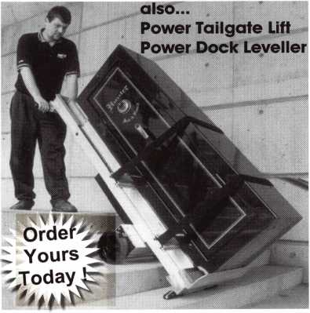

Many models to choose from:

**PowerMate M-1** 1500 lb. Capacity **40”+ Lift** **to** Tailgate

Built-in 4 Wheel

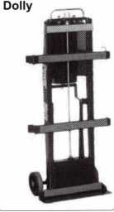

Power safes, ATMs, vault doors, etc. up/down stairs and on/off vehicles safely and quickly at the push of a button. Because PowerMate® does 100% of the lifting, there is no strain on your back or legs.

More secure handling results in less risk of damage to your productsand/orclient’sstairs,wallsandfloors,saving money!

1*-*800*-*697-6283

[www.lpinternational.com](http://www.lpinternational.com)

Keynotes • June 2002



**Distributor**

ADI Inc

Phone: 631-692-1000 Fax: 631-692-3011

Accredited Lock Supply Co.

Phone: 201-865-5015 Fax: 201-865-0030

[www.acclock.com](http://www.acclock.com)

Ace Lock & Security Supply

Phone: 908-688-7666 Fax: 908-688-2442

[www.acelock.com](http://www.acelock.com)

Action Hardware Inc.

Phone: 800-662-6695 Fax: 800-930-2329

Andrews Wholesale Lock Supply

Phone: 717-272-7422 Fax: 717-274-8659

Boyle & Chase Inc.

Phone: 800-325-2530 Fax: 800-205-3500

[www.boyleandchase.com](http://www.boyleandchase.com)

COMPX Security Products

Phone: 864-297-6655 Fax: 864-297-9987

[www.nclnet.com](http://www.nclnet.com)

Clark Security Products

Phone: 800-854-2088 Fax: 619-974-5284

Cook's Building Specialties

Phone: 505-883-5701 Fax: 505-883-5704

Dire's Lock & Key Com­pany

Phone: 303-294-0176 Fax: 303-294-0198

Direct Security Supply, Inc.

Phone: 800-252-5757 Fax: 800-452-8600

Doyle Security Products

Phone: 800-333-6953 Fax: 612-521-0166

[www.doylesecurity.com](http://www.doylesecurity.com)

Dugmore and Duncan, Inc.

Phone: 888-384-6673 Fax: 888-329-3846

E. L. Reinhardt Co., Inc.

Phone: 800-328-1311 Fax: 651-481-0166

[www.elreinhardt.com](http://www.elreinhardt.com)

Ewert Wholesale Hardware

Phone: 800-451-0200 Fax: 708-597-0881

Fairway Supply, Inc.

Phone: 214-350-0021 Fax: 214-352-4299

[www.fairwaysupply.com](http://www.fairwaysupply.com)

Foley-Belsaw Company

Phone: 800-821-3452 Fax: 816-483-5010

[www.belsaw.com](http://www.belsaw.com)

Fried Brothers Inc.

Phone: 800-523-2924 Fax: 215-592-1255

H L Flake Co.

Phone: 800-231-4105 Fax: 713-926-3399

[www.hlflake.com](http://www.hlflake.com)

H.S. & S.

Wholesale Distrib.

Phone: 313-342-6777 Fax: 313-342-7580

Hans Johnsen Company

Phone: 214-879-1550 Fax: 214-879-1530

Phone: 416-462-1921

Howard Keys

Phone: 704-509-4944 Fax: 704-509-6248

[www.howa](http://www.howa) rd keys .com

IDN Incorporated

Phone: 817-421-5470 Fax: 817-421-5468

Intermountain Lock & Supply

Phone: 800-453-5386 Fax: 801-485-7205

[www.intermountainlock.com](http://www.intermountainlock.com)

Jensen Tools Inc.

Phone: 602-453-3169 Fax: 602-438-1690

Jo Van Distributors

Phone: 416-752-2238 Fax: 416-752-7282

Lockmasters, Inc.

Phone: 859-885-6041 Fax: 859-885-7093

[www.lockmasters.com](http://www.lockmasters.com)

Locks Company

Phone: 800-288-0801 Fax: 305-949-3619

M. Zion Company

Phone: 212-349-8677 Fax: 212-964-0495

Massglass & Door Service

Phone: 888-742-8837 Fax: 818-991-5742

[www.massglass.com](http://www.massglass.com)

McDonald Dash Locksmith Supply

Phone: 800-238-7541 Fax: 901-366-0005

[www.mcdonalddash.com](http://www.mcdonalddash.com)

McManus Locksmith Supply, Inc.

Phone: 704-333-9112 Fax: 704-332-8664

Monaco Lock Co.

Phone: 800-526-6094 Fax: 800-845-5625

[www.monacolock.com](http://www.monacolock.com)

Phone: 800-238-4566 Fax: 402-444-1664

[www.omahawh.com](http://www.omahawh.com)

Phoenix Safe International LLC

Phone: 765-483-0954 Fax: 765-483-0962

[www.phoenixsafeusa.com](http://www.phoenixsafeusa.com)

SecureRite.Com

Phone: 800-241-3930 Fax: 858-974-5269

[www.SecureRite.Corn](http://www.SecureRite.Corn)

Sentry Security Fasteners

Phone: 309-693-2800 Fax: 800-693-2872

Somerset Security Products

Phone: 800-881-5206 Fax: 800-206-9949

Southern Lock and Supply Co.

Phone: 727-541-5536 Fax: 727-544-8278

southernlock.com

Stone & Berg Wholesale

Phone: 800-225-7405 Fax: 800-535-5625

Taylor Security & Lock

Phone: 301-948-7670 Fax: 301-948-1029

[www.taylorsecurity.com](http://www.taylorsecurity.com)

The Locksmith Store Inc.

Phone: 847-364-5111 Fax: 847-364-5125

[www.locksmithstore.com](http://www.locksmithstore.com)

Timemaster Inc.

Phone: 888-798-8465 Fax: 800-798-8463

[www.time-master.com](http://www.time-master.com)

Top Notch Distributors, Inc.

Phone: 800-233-4210 Fax: 800-854-4146

[www.4topnotch.com](http://www.4topnotch.com)

U.S. Lock Corp.

Phone: 800-925-5000 Fax: 800-338-5625

[www.uslock.com](http://www.uslock.com)

Webster Safe & Lock Co., Inc.

Phone: 901-332-2911 Fax: 901-332-2878

webstersinc.com

**Manufacturer**

A & B Safe Corporation

Phone: 800-253-1267 Fax: 856-863-1208

[www.a-bsafecorp.com](http://www.a-bsafecorp.com)

Abloy Door Security

Phone: 800-465-5761 Fax: 514-335-0430

[www.abloy.com](http://www.abloy.com)

Adams Rite Mfg. Company

Phone: 800-872-3267 Fax: 800-232-7329

[www.adamsrite.com](http://www.adamsrite.com)

Adesco Safe Mfg. Company

Phone: 800-821-6803 Fax: 562-408-6427

[www.adesco.com](http://www.adesco.com)

Adrian Steel Company

Phone: 800-677-2726 Fax: 517-265-5834

[www.adriansteel.com](http://www.adriansteel.com)

Alarm Lock Systems Inc.

Phone: 800-252-5625 Fax: 516-789-3383

[www.alarmlock.com](http://www.alarmlock.com)

All Five Tool Company, Inc.

Phone: 860-583-1691 Fax: 860-583-4516

[www.all5tool.com](http://www.all5tool.com)

American Lock Company

Phone: 708-534-2000 Fax: 708-534-0531

American Security Products

Phone: 909-685-9680X1083 Fax: 909-685-9685

[www.amsecusa.com](http://www.amsecusa.com)

BWD Automotive

Phone: 334-872-6524 Fax: 334-874-6011

[www.bwdautomotive.com](http://www.bwdautomotive.com)

Baldwin Hardware

Phone: 610-796-4012 Fax: 610-796-4493

Buddy Products

Phone: 800-886-8688 Fax: 312-733-8356

[www.buddyontheweb.com](http://www.buddyontheweb.com)

Curtis Industries, A Barnes Distribution

Phone: 800-555-5397 Fax: 800-867-6020

[www.curtisindustries.com](http://www.curtisindustries.com)

Hardware Agencies, Ltd. Omaha Wholesale

Hardware



Keynotes • June 2002

|  |  |  |
| --- | --- | --- |
| a | s s o c i a 1 | t e |
|  | members |  |

DETEX Corporation

Phone: 800-729-3839 Fax: 830-620-6711

DORMA Architectural Hardware

Phone: 717-336-3881 Fax: 717-336-3500

[www.dorma-usa.com](http://www.dorma-usa.com)

Don-Jo

Manufacturing, Inc.

Phone: 978-422-3213 Fax: 978-422-3467

[www.don-jo.com](http://www.don-jo.com)

Door Controls International

Phone: 800-742-3634 Fax: 800-742-0410

[www.doorcontrols.com](http://www.doorcontrols.com)

ESP Lock Products Inc.

Phone: 978-562-3481 Fax: 978-562-9859

FireKing

Security Products

Phone: 800-457-2424 Fax: 800-896-6606

[www.fireking.com](http://www.fireking.com)

HES, Inc.

Phone: 623-582-4626 Fax: 623-582-4641

[www.hesinnovations.com](http://www.hesinnovations.com)

HPC, Inc.

Phone: 847-671-6280 Fax: 847-671-6343

[www.hpcworld.com](http://www.hpcworld.com)

Hongtai Lock Co. Ltd.

Phone: 137-238-1414 Fax: 208-793-3856

INTELLIKEY Corp.

Phone: 800-226-0703 Fax: 321-724-0811

[www.intellikey.com](http://www.intellikey.com)

llco Unican

Phone: 252-446-3321 Fax: 252-446-4702

[www.kaba-ilco.com](http://www.kaba-ilco.com)

Jet Hardware Mfg., Co.

Phone: 718-257-9600 Fax: 718-257-0973

KABA High Security Locks

Phone: 860-621-3601 Fax: 860-621-9727

[www.kabausa.com](http://www.kabausa.com)

KEY-BAK/West Coast Chain Mfg.

Phone: 909-923-7800 Fax: 909-923-0024

[www.keybak.com](http://www.keybak.com)

Keri Systems Inc.

Phone: 408-451-2520 Fax: 408-441-0309

[www.kerisys.com](http://www.kerisys.com)

Knaack Manufacturing Co.

Phone: 800-456-7865 Fax: 815-459-9097

[www.weatherguard.com](http://www.weatherguard.com)

LAB Security

Phone: 800-243-8242 Fax: 860-583-7838

[www.labpins.com](http://www.labpins.com)

LCN C losers/Div. of Ingersoll

Phone: 815-875-3311 Fax: 815-879-1497

[www.lcnclosers.com](http://www.lcnclosers.com)

La Gard Inc.

Phone: 310-325-5670 Fax: 310-325-5615

[www.lagard.com](http://www.lagard.com)

Locksmith Ledger International

Phone: 770-886-0800 Fax: 770-889-7703

lledger.com

Lucky Line Products, Inc.

Phone: 858-549-6699 Fax: 858-549-3241

M.A.G. Security

Phone: 714-891-5100 Fax: 714-892-6845

[www.magsecurity.com](http://www.magsecurity.com)

MARKS, U.S.A.

Phone: 516-225-5400 Fax: 516-225-6136

[www.marksusa.com](http://www.marksusa.com)

MARRAY ENTERPRISES

Phone: 408-970-0213 Fax: 408-970-8767

[www.marray.com](http://www.marray.com)

MCS Communication Systems

Phone: 514-444-2040 Fax: 514-444-2029

[www.mcscommunication.com](http://www.mcscommunication.com)

MMD, Inc.

Phone: 865-428-3611 Fax: 865-453-4136

MUL-T-LOCK USA, Inc.

Phone: 800-562-3511 Fax: 973-778-4007

[www.mul-t-lock.com](http://www.mul-t-lock.com)

Master Lock Company

Phone: 414-444-2800 Fax: 414-444-0322

[www.masterlock.com](http://www.masterlock.com)

Medeco Security Locks

Phone: 540-380-5000 Fax: 540-380-5010

[www.medeco.com](http://www.medeco.com)

NKL Industries Inc.

Phone: 800-528-9900 Fax: 757-485-0271

[www.nklindustries.com/](http://www.nklindustries.com/) products_NKL/index.htm

Pro Steel

Phone: 801-373-2385 Fax: 801-373-2399

[www.pro-steel](http://www.pro-steel) .net

ROFU International Corp.

Phone: 800-255-7638 Fax: 253-922-1728

[www.rofu.com](http://www.rofu.com)

Rutherford Controls Inti. Co.

Phone: 757-427-1230 Fax: 757-427-9549

[www.rutherfordcontrols.com](http://www.rutherfordcontrols.com)

STRATTEC Security Corp.

Phone: 414-247-3415 Fax: 414-247-3692

Sargent & Greenleaf, Inc.

Phone: 859-885-9411 Fax: 859-885-3063

[www.sglocks.com](http://www.sglocks.com)

Sargent

Manufacturing Co.

Phone: 203-562-2151 Fax: 203-776-5992

Schlage Lock Co.

Phone: 719-264-5300 Fax: 719-264-5382

[www.schlagelock.com](http://www.schlagelock.com)

Schwab Corp.

Phone: 765-447-9470 Fax: 765-447-8278

[www.schwabcorp.com](http://www.schwabcorp.com)

Securitron Magnalock Corp.

Phone: 775-355-5626 Fax: 775-355-5636

[www.securitron.com](http://www.securitron.com)

Security Door Controls

Phone: 805-494-0622 Fax: 805-494-8861

[www.sdcsecurity.com](http://www.sdcsecurity.com)

Security Solutions

Phone: 405-376-1600 Fax: 405-376-6870

Sentry Group

Phone: 716-381-4900 Fax: 716-381-8559

[www.sentrysafe.com](http://www.sentrysafe.com)

Sully Tools Inc.

Phone: 703-689-3416 Fax: 703-787-0869

[www.sullytools.com](http://www.sullytools.com)

SunSafes

Manufacturing Co.

Phone: 823-194-59300 Fax: 823-194-59400

[www.eaglesafes.com](http://www.eaglesafes.com)

Taymor Industries, Inc.

Phone: 800-388-9887 Fax: 800-288-8133

Trine Access Technology

Phone: 718-829-2332 Fax: 718-829-6405

[www.trineonline.com](http://www.trineonline.com)

Videx Inc.

Phone: 541-758-0521 Fax: 541-752-5285

W-LOK Corporation

Phone: 616-355-4015 Fax: 616-355-4295

[www.wlokcorp.com](http://www.wlokcorp.com)

Yale Security Group, Inc.

Phone: 800-438-1951 Fax: 800-338-0965

**Service Organization**

Allstate Insurance Company

Phone: 847-402-8196 Fax: 847-326-7509

[www.allstate.com](http://www.allstate.com)

Emergency Road Ser­vice Inc.

Phone: 888-839-5386 Fax: 678-277-8105

Professional Business Products

Phone: 800-258-6219 Fax: 813-888-5393

The National Locksmith

Phone: 630-837-2044 Fax: 630-837-1210

[www.thenationallocksmith.com](http://www.thenationallocksmith.com)

Keynotes • June 2002

back page

About the Authors

Greg Perry, CML, CPS has been in the locksmith  
industry for 19 years. He’s spent half of that time as  
a field technician for Security Engineering in  
Ridgecrest, CA. Greg is also a past president of the  
Desert Counties Chapter of the California Locksmiths  
Association.

Sal Dulcamaro, CML, has been in the security  
industry for over 26 years. He is the president of All  
Pro Security, Inc. in Michigan and has been an ALOA  
member for 19 years. A past president of the  
Locksmith Security Association of Michigan, Sal cur-  
rently serves as web editor of the association’s on-  
line newsletter. He was named Keynotes “Author of  
the Year” in both 1996 and 1997. He is also a con-  
tributing editor for Keynotes. Find Sal on the Internet  
at: <<http://www.home.earthlink.net/~lockwriter>>.

Tom Seroogy is in the new Automotive division of  
Lockmasters. He has been the Product Manager for

BWD Automotive (formerly known as All

Lock). His many years of technical  
expertise in the automotive field and  
as a contributor to automotive lock-  
smith education have created a  
much sought after demand for his  
popular classes. Tom has developed  
the new Automotive Locksmithing I &

II classes for ALOA to help prepare locksmiths for the PRP automotive electives.

Mike Griffin owns and operates Griffin Enterprises Chesterfield, SC.

You can reach him by e-mail at: safesrus@mecsc. net.



**Ad Index**

|  |  |
| --- | --- |
| Dynalock | Inside Front Cover |
| Stam | 5 |
| SAVTA | Inside Back Cover |
| Hickok | Back Cover |

Keynotes • June 2002

*Only)*

Order Today!  
**(**800**)**532-2562

33

Bulletins

CD!

on

ne

The TB's are sold to SAVTA members only.  
If you're not a member but would like  
the TB's, join SAVTA with your order and  
we will waive the $50 membership

application fee.

All of the SAVTA Technical Bulletins from 1988 through 2001 - that's 336 Bulletins - have been conveniently stored on one CD. The format allows the user to search the TB's in several ways. The TB's can be printed. The templates that are on the back page of many bulletins will print to scale. The CD makes the Bulletins much easier to use and to transport.

New Bulletins will be added each year for an additional charge.

only

**>**195**!**

These bulletins, in the printed format, would cost for $1,400. The price on CD is only $195.00, plus shipping.

For those not familiar with the TB's, each TB contains the specifications of a container. These specs include the data necessary- boltwork, hardplate, relock­ers, drill points - to assist with openings.

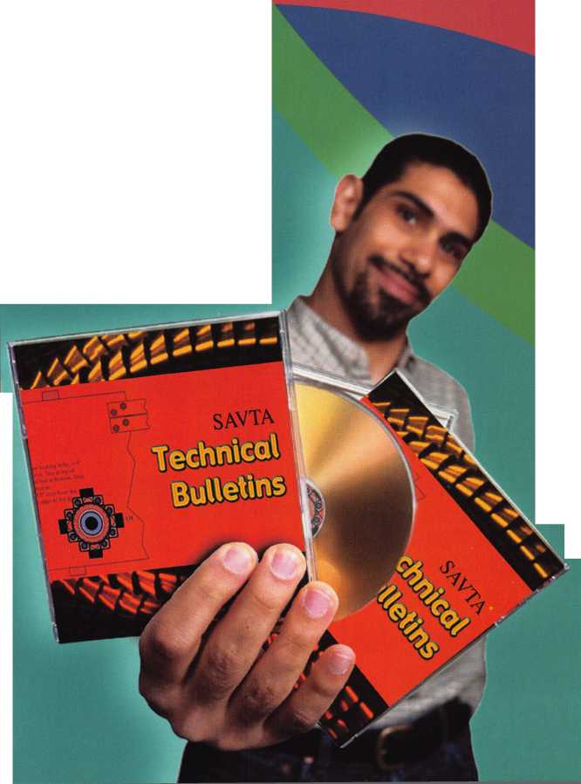

fipsi

°P date's

e"P° , ;xiaW^

**" Jump ahead of the competition at warp speed and see your profits soar.**

|  |  |  |  |  |  |  |
| --- | --- | --- | --- | --- | --- | --- |
| pr |  |  |  | f r | A |  |
|  |  |  |  | Vl | y J |  |

**Hickok’s New Generation STAR transports you with the factory tool for programming keys to  
Ford-Lincoln-Mercury and Mazda vehicles with passive anti theft systems (PATS).**

**Program vehicle keys through Model Year 2001 with Hickok’s NGS Model 800-8LA-$1995 ^ Update your existing software-the 2001 Complete New Model Ford Software Update Model 80LA-$895**

**800**/**342-5080**

**HICKOK**

**INCORPORATED**

uiivui.hickok-inc.ee

